Thai in Thailand Video Transcripts
Language by Country Collection on LangMedia
http://langmedia.fivecolleges.edu/

"Greeting Guests"

Thai transcript:
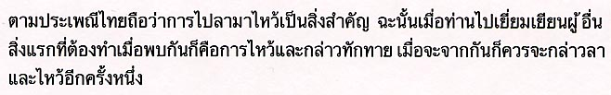

English translation:
"According to Thai tradition, Thai people always believe that greeting others, when you meet them, and saying goodbye are important. Hence, when you go to visit other people, the first thing you have to do when you meet them is to put your hands together at your chest and bow, and when you are leaving you have to do the same thing again."

About Language by Country: The Language by Country videos and other materials were produced by the Five College Center for the Study of World Languages between 1999 - 2003 with funding from the National Security Education Program (NSEP) and the Fund for the Improvement of Postsecondary Education (FIPSE) of the U.S. Department of Education. The videos were filmed by Five College international students in their home countries. The goal was to provide examples of authentic language spoken in its natural cultural environment so that students of all ages can better understand the interplay between a language and its culture. We have tried to remain true to the language our subjects actually uttered. Therefore, we have not corrected grammatical errors and the videos sometimes show highly colloquial language, local slang, and regionally specific speech patterns. At times, we have noted the preferred or more standard forms in parentheses. Most of the transcripts and translations were prepared by the same students who filmed the video, although in some cases the transcripts have also been edited by a language expert.
© 2003 Five College Center for the Study of World Languages and Five Colleges, Incorporated

