French and Wolof in Senegal Video Transcripts
Language by Country Collection on LangMedia
http://langmedia.fivecolleges.edu/

"Introducing a Friend to a Sister"

Wolof transcript:
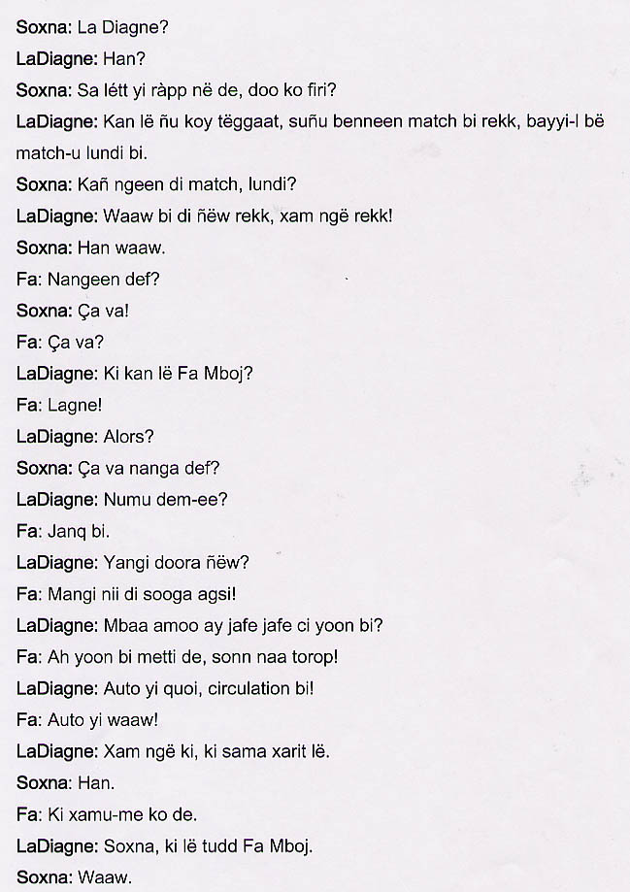
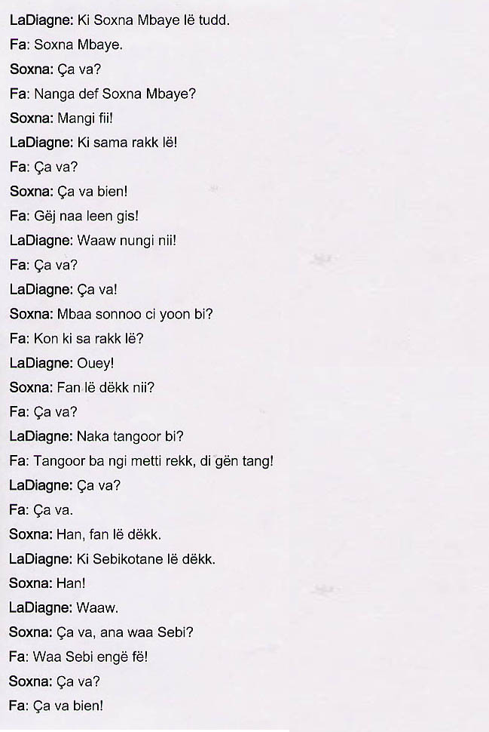

English translation:
"Soxna: LaDiagne.
LaDiagne: Yes.
Soxna: Aren't you going to take out your braids, they're old now!
LaDiagne: When are we going to redo them. Let's wait until our next game, wait until Monday's game.
Soxna: You have a game on Monday?
LaDiagne: Yes, next Monday, you know.
Soxna: All right, then.
Fa: How are you all?
Soxna: Fine, thank you.
Fa: Hi!
LaDiagne: Hey, is this Fa Mboj?
Fa: Lagne!
LaDiagne: Hey, what's up?
Fa: Hi, how are you?
LaDiagne: How is it going?
Fa: Sister!
LaDiagne: Did you just arrived?
Fa: Yes, I just got here!
LaDiagne: I hope your trip was not too tiring.
Fa: Unfortunately, it was. I am very tired at this point.
LaDiagne: Because of traffic, I suppose.
Fa: Yeah, the cars.
LaDiagne: Do you know her? This is a friend of mine.
Soxna: All right.
Fa: No, I do not know her.
LaDiagne: Soxna, this is Fa Mboj.
Soxna: Okay.
LaDiagne: And this is Soxna Mbaye.
Fa: Soxna Mbaye.
Soxna: How are you?
Fa: How are you Soxna Mbaye?
LaDiagne: This is my younger sister.
Fa: How are you?
Soxna: I am fine. Thank you!
Fa: I haven't seen you for a long time!
LaDiagne: As you can see, here we are.
Fa: How are you?
LaDiagne: Fine, thanks.
Soxna: I hope the trip was not too tiring.
Fa: So this is your little sister.
LaDiagne: Yeah.
Soxna: Where does she live?
Fa: How are you?
LaDiagne: How are you doing with the heat?
Fa: It's hard to cope with it. It gets hotter every day!
LaDiagne: How are you?
Fa: Fine, thanks.
Soxna: Where does she live?
LaDiagne: She lives in Sebikotane!
Soxna: Really?
LaDiagne: Yes.
Soxna: How is everyone back there?
Fa: Everyone is fine.
Soxna: How are you?
Fa: I am fine. Thank you."

About Language by Country: The Language by Country videos and other materials were produced by the Five College Center for the Study of World Languages between 1999 - 2003 with funding from the National Security Education Program (NSEP) and the Fund for the Improvement of Postsecondary Education (FIPSE) of the U.S. Department of Education. The videos were filmed by Five College international students in their home countries. The goal was to provide examples of authentic language spoken in its natural cultural environment so that students of all ages can better understand the interplay between a language and its culture. We have tried to remain true to the language our subjects actually uttered. Therefore, we have not corrected grammatical errors and the videos sometimes show highly colloquial language, local slang, and regionally specific speech patterns. At times, we have noted the preferred or more standard forms in parentheses. Most of the transcripts and translations were prepared by the same students who filmed the video, although in some cases the transcripts have also been edited by a language expert.
© 2003 Five College Center for the Study of World Languages and Five Colleges, Incorporated

