French and Wolof in Senegal Video Transcripts
Language by Country Collection on LangMedia
http://langmedia.fivecolleges.edu/

"Let's Go Out!"

Wolof transcript:
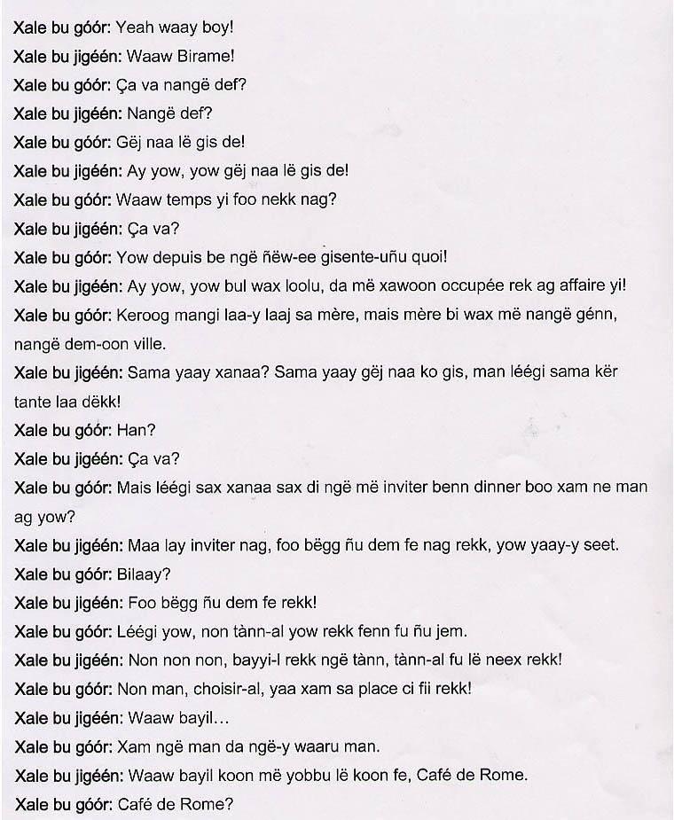
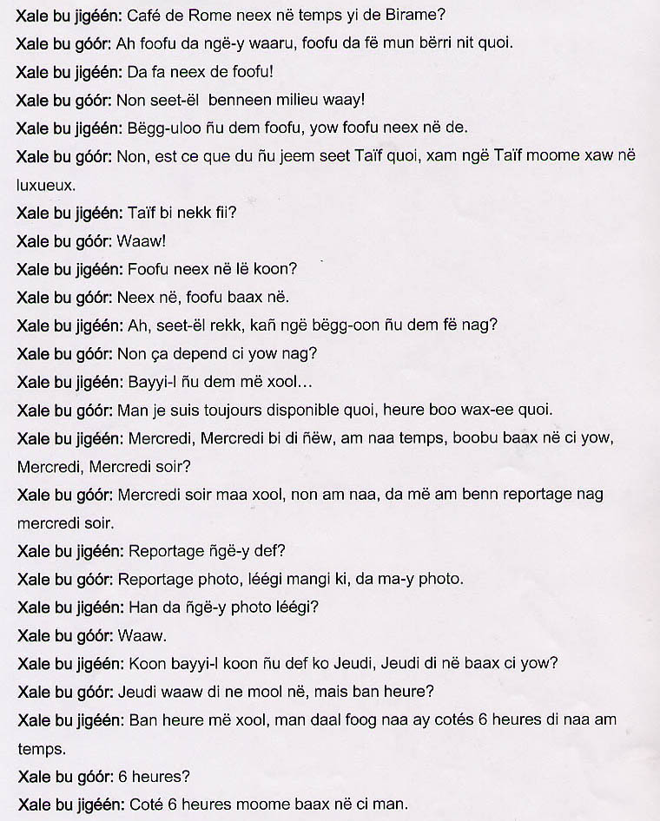
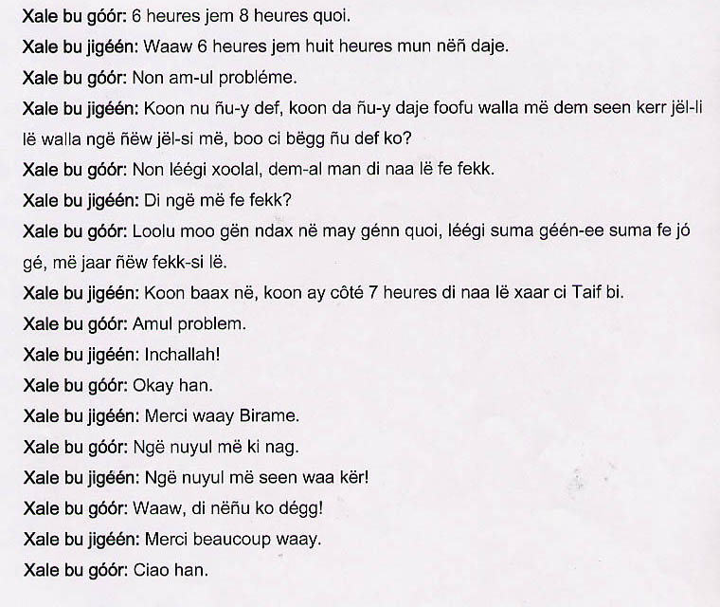

English translation:
"Young man: Yo, girl!
Young woman: Yeah, Birame.
Young man: How are you?
Young woman: How are you?
Young man: I haven't seen you in a long time?
Young woman: Me, neither!
Young man: Where have you been lately?
Young woman: What's up?
Young man: We haven't seen each other since you came back!
Young woman: Come on, don't say that. I have just been very busy.
Young man: I asked your mother about you last time, but she told me you were out. You went to the city.
Young woman: My mother? Right, I haven't seen her in a long time. I live at my aunt's now.
Young man: Oh, really?
Young woman: So, how are you?
Young man: So now, I hope you will invite me out for dinner or something?
Young woman: I sure will. You pick the place.
Young man: For real?
Young woman: Yes, wherever you want.
Young man: Well, why don't you pick a place that we can go.
Young woman: No, let's just have you pick the place. Pick a place that you like.
Young man: No, you choose a spot. You know what you like around here.
Young woman: All right.
Young man: You know me.
Young woman: All right. So let me take you to the Café de Rome.
Young man: Café de Rome?
Young woman: Yeah, it's been a very nice spot lately.
Young man: You know, that place is not all that great. There are too many people there.
Young woman: It is a very nice place!
Young man: No, pick another one.
Young woman: You don't want to go there? That place is very nice.
Young man: Why don't we try the Taif? It is a very luxurious place.
Young woman: The Taif, right here?
Young man: Yes.
Young woman: You like it there?
Young man: I think it's a nice place.
Young woman: Well, you choose. When do you want us to go for dinner, then?
Young man: It depends on you, now.
Young woman: Let me see. Let's go on…
Young man: I am always available, so anytime you want is fine.
Young woman: Wednesday, I'll be free next Wednesday. Does that work for you, Wednesday night?
Young man: Wednesday night, let's see…no. I have a coverage assignment Wednesday night.
Young woman: You do coverage?
Young man: Yes, coverage. I am photographer now.
Young woman: Really, so you are a photographer now?
Young man: Yes.
Young woman: So, let's do it on Thursday. Is Thursday good for you?
Young man: Yes, Thursday is great. What time?
Young woman: Let me think. What time? I think I will be free at around 6:00 p.m.
Young man: 6:00 pm?
Young woman: Yes, 6:00 p.m. is actually a good time for me.
Young man: So let's say between 6:00 p.m. and 8:00 p.m.
Young woman: Yes, we can meet between 6:00 p.m. and 8:00 p.m., then.
Young man: All right, no problem.
Young woman: So where are we meeting first? Should I go ahead and meet you at the restaurant, or should I come pick you up or you come pick me up? What would you like to do?
Young man: No, look, why don't you go ahead, and I'll join you at the place.
Young woman: You'll join me there?
Young man: Yes, I think that is better because I'll be out, so when I come back I will simply come join you at the restaurant.
Young woman: Good enough, so I'll be at the Taif at around 7:00 p.m. waiting for you.
Young man: No problem.
Young woman: With God's will.
Young man: All right.
Young woman: Thanks Birame!
Young man: My greetings to…
Young woman: Say hello to your family.
Young man: Yes, I'll tell them!
Young woman: Thank you again!
Young man: All right, bye!"

About Language by Country: The Language by Country videos and other materials were produced by the Five College Center for the Study of World Languages between 1999 - 2003 with funding from the National Security Education Program (NSEP) and the Fund for the Improvement of Postsecondary Education (FIPSE) of the U.S. Department of Education. The videos were filmed by Five College international students in their home countries. The goal was to provide examples of authentic language spoken in its natural cultural environment so that students of all ages can better understand the interplay between a language and its culture. We have tried to remain true to the language our subjects actually uttered. Therefore, we have not corrected grammatical errors and the videos sometimes show highly colloquial language, local slang, and regionally specific speech patterns. At times, we have noted the preferred or more standard forms in parentheses. Most of the transcripts and translations were prepared by the same students who filmed the video, although in some cases the transcripts have also been edited by a language expert.
© 2003 Five College Center for the Study of World Languages and Five Colleges, Incorporated

