French and Wolof in Senegal Video Transcripts
Language by Country Collection on LangMedia
http://langmedia.fivecolleges.edu/

"Ordering at a Restaurant"

Wolof and French transcript:
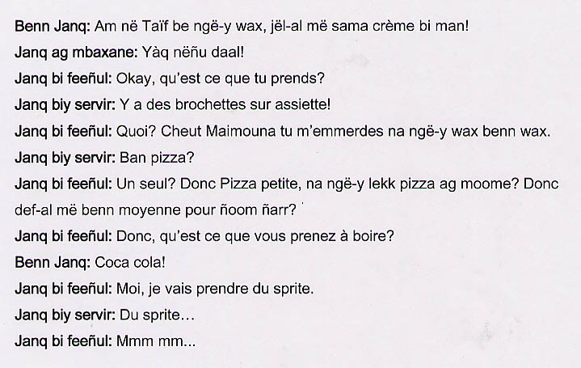

English translation:
"A young woman: You are saying that they have at the Taïf, just get me ice cream!
Young woman with the hat: They certainly spoiled it!
Off-screen young woman: All right, what are you getting?
Waitress: We have brochettes on a plate.
Off-screen young woman: What? Maimouna, you are really getting on my nerves. Make up your mind!
Waitress: What kind of pizza?
Off-screen young woman: Just one? One small pizza then, do you want to eat the pizza with her? So, a medium pizza for them.
Off-screen young woman: What do you guys want to drink?
A young woman: Coke!
Off-screen young woman: I am going to have Sprite.
Waitress: Sprite.
Off-screen young woman: Yes."

About Language by Country: The Language by Country videos and other materials were produced by the Five College Center for the Study of World Languages between 1999 - 2003 with funding from the National Security Education Program (NSEP) and the Fund for the Improvement of Postsecondary Education (FIPSE) of the U.S. Department of Education. The videos were filmed by Five College international students in their home countries. The goal was to provide examples of authentic language spoken in its natural cultural environment so that students of all ages can better understand the interplay between a language and its culture. We have tried to remain true to the language our subjects actually uttered. Therefore, we have not corrected grammatical errors and the videos sometimes show highly colloquial language, local slang, and regionally specific speech patterns. At times, we have noted the preferred or more standard forms in parentheses. Most of the transcripts and translations were prepared by the same students who filmed the video, although in some cases the transcripts have also been edited by a language expert.
© 2003 Five College Center for the Study of World Languages and Five Colleges, Incorporated

