Slovak in Slovakia Video Transcripts
Language by Country Collection on LangMedia
http://langmedia.fivecolleges.edu/

"At a Hotel"

Slovak transcript:
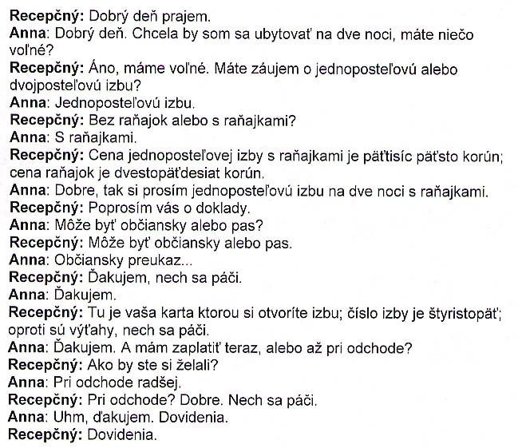

English translation:
"Receptionist: Hello.
Anna: Hello. I'd like to get a room for two nights. Do you have anything available?
Receptionist: Yes, we do. Are you interested in a single or a double?
Anna: A single.
Receptionist: Without or with breakfast?
Anna: With breakfast.
Receptionist: The price for a single with breakfast is 5,500 crowns; the price of breakfast is 250 crowns.
Anna: Okay, I'd like a single for two nights with breakfast.
Receptionist: Can I see your identification documents, please?
Anna: Is either a citizen's ID or a passport okay?
Receptionist: Either a citizen's ID or a passport is okay.
Anna: A citizen's identity card...
Receptionist: Thank you, this is yours.
Anna: Thank you.
Receptionist: This is your card with which you'll open your room. Your room number is 405. The elevators are over there.
Anna: Thank you. And do I have to pay now or upon departure?
Receptionist: How would you prefer?
Anna: Upon departure, rather.
Receptionist: Upon departure? Okay. As you wish.
Anna: Uhm, thank you, see you later.
Receptionist: See you later."

About Language by Country: The Language by Country videos and other materials were produced by the Five College Center for the Study of World Languages between 1999 - 2003 with funding from the National Security Education Program (NSEP) and the Fund for the Improvement of Postsecondary Education (FIPSE) of the U.S. Department of Education. The videos were filmed by Five College international students in their home countries. The goal was to provide examples of authentic language spoken in its natural cultural environment so that students of all ages can better understand the interplay between a language and its culture. We have tried to remain true to the language our subjects actually uttered. Therefore, we have not corrected grammatical errors and the videos sometimes show highly colloquial language, local slang, and regionally specific speech patterns. At times, we have noted the preferred or more standard forms in parentheses. Most of the transcripts and translations were prepared by the same students who filmed the video, although in some cases the transcripts have also been edited by a language expert.
© 2003 Five College Center for the Study of World Languages and Five Colleges, Incorporated

