Slovak in Slovakia Video Transcripts
Language by Country Collection on LangMedia
http://langmedia.fivecolleges.edu/

"Buying a Tramway Ticket From a Machine"

Slovak transcript:
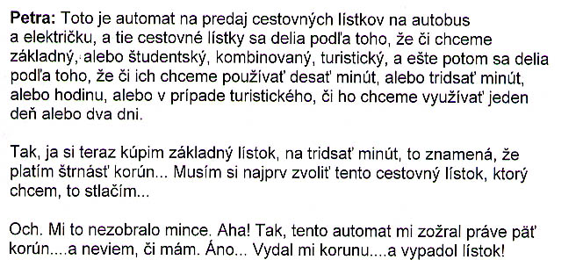

English translation:
"Petra: This is a machine that sells bus and tram tickets, and the tickets differ based on whether we want a basic (ticket), or a student, a combined, or a tourist, and also based on whether we want to use them for ten minutes, or thirty minutes, or an hour, or, in the case of the tourist, whether we want to use it for one day or two days.
So, I'm now going to buy a basic ticket for thirty minutes which means that I pay fourteen crowns. I first have to select the ticket that I want. I press here...
Ooops. It didn't take my coins. I see! So, this machine just ate my five crowns...and I don't know if I have [enough]. Yes...It gave me back one crown...and a ticket came out!"

About Language by Country: The Language by Country videos and other materials were produced by the Five College Center for the Study of World Languages between 1999 - 2003 with funding from the National Security Education Program (NSEP) and the Fund for the Improvement of Postsecondary Education (FIPSE) of the U.S. Department of Education. The videos were filmed by Five College international students in their home countries. The goal was to provide examples of authentic language spoken in its natural cultural environment so that students of all ages can better understand the interplay between a language and its culture. We have tried to remain true to the language our subjects actually uttered. Therefore, we have not corrected grammatical errors and the videos sometimes show highly colloquial language, local slang, and regionally specific speech patterns. At times, we have noted the preferred or more standard forms in parentheses. Most of the transcripts and translations were prepared by the same students who filmed the video, although in some cases the transcripts have also been edited by a language expert.
© 2003 Five College Center for the Study of World Languages and Five Colleges, Incorporated

