Slovak in Slovakia Video Transcripts
Language by Country Collection on LangMedia
http://langmedia.fivecolleges.edu/

"At a Commercial Cleaner"

Slovak transcript:
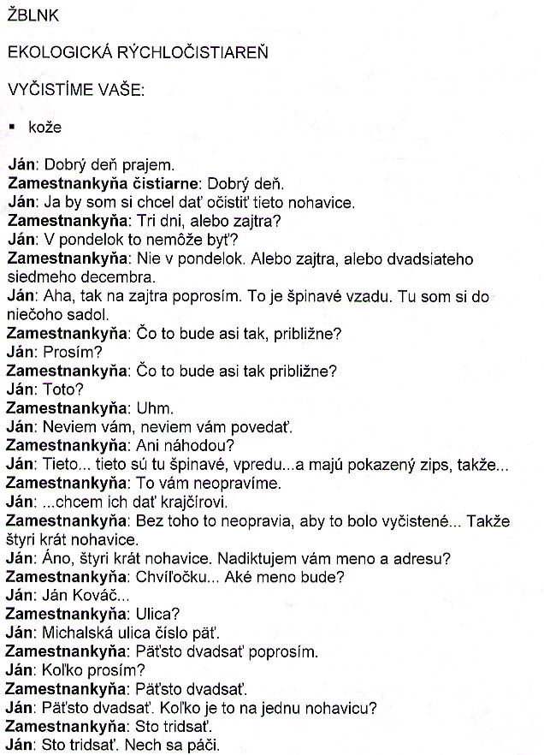
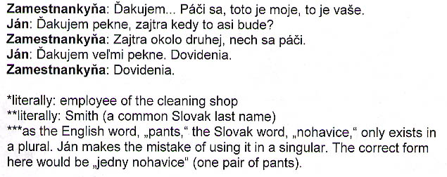

English translation:
"SPLASH
ECOLOGICAL SPEEDY CLEANER
WE'LL CLEAN YOUR:
§ leathers
Ján: Hello.
Attendant: Hello.
Ján: I would like to have these pants cleaned.
Attendant: Three days, or tomorrow?
Ján: Can't it be on Monday?
Attendant: Not on Monday. Either tomorrow, or on December twenty-seventh.
Ján: I see, then I'll ask for tomorrow. This is dirty in the back...
Attendant: What is it, more or less?
Ján: Excuse me?
Attendant: What is it, more or less?
Ján: This?
Attendant: Uhm.
Ján: I've no.. I've no idea.
Attendant: No chance [that you know]?
Ján: These...these are dirty here in front...and they have a broken zipper, so...
Attendant: We won't fix that for you.
Ján: ...I want to take them to a tailor.
Attendant: They won't fix it unless it's clean... So, pants four times.
Ján: Yes, pants four times . Shall I give you my name and address?
Attendant: Just a sec... What's the name?
Ján: Ján Kovác*...
Attendant: Street ?
Ján: Michalská street, number five.
Attendant: Five hundred and twenty, please.
Ján: Excuse me, how much?
Attendant: Five hundred and twenty.
Ján: Five hundred and twenty. How much is it for one pair of pants?**
Attendant: A hundred and thirty.
Ján: A hundred and thirty. Here you are.
Attendant: Thank you... Here you go, this is mine, that's yours.
Ján: Thank you very much. Tomorrow at what time, approximately?
Attendant: Tomorrow around two.
Ján: Thank you very much. Bye.
Attendant: Bye.
*literally: Smith (a common Slovak last name)
**Like the English word „pants„ the Slovak word „nohavice„ only exists in a plural. Ján makes the mistake of using it in a singular. The correct form here would be „jedny nohavice„ (one pair of pants)."

About Language by Country: The Language by Country videos and other materials were produced by the Five College Center for the Study of World Languages between 1999 - 2003 with funding from the National Security Education Program (NSEP) and the Fund for the Improvement of Postsecondary Education (FIPSE) of the U.S. Department of Education. The videos were filmed by Five College international students in their home countries. The goal was to provide examples of authentic language spoken in its natural cultural environment so that students of all ages can better understand the interplay between a language and its culture. We have tried to remain true to the language our subjects actually uttered. Therefore, we have not corrected grammatical errors and the videos sometimes show highly colloquial language, local slang, and regionally specific speech patterns. At times, we have noted the preferred or more standard forms in parentheses. Most of the transcripts and translations were prepared by the same students who filmed the video, although in some cases the transcripts have also been edited by a language expert.
© 2003 Five College Center for the Study of World Languages and Five Colleges, Incorporated

