Slovak in Slovakia Video Transcripts
Language by Country Collection on LangMedia
http://langmedia.fivecolleges.edu/

"The year 1945"

Slovak transcript:
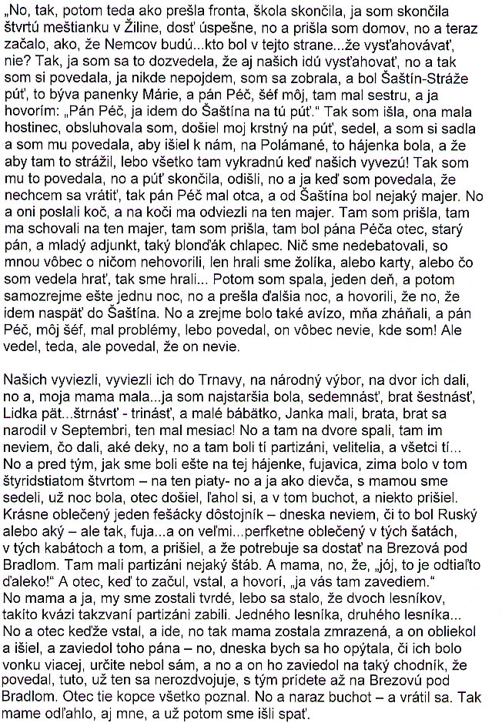
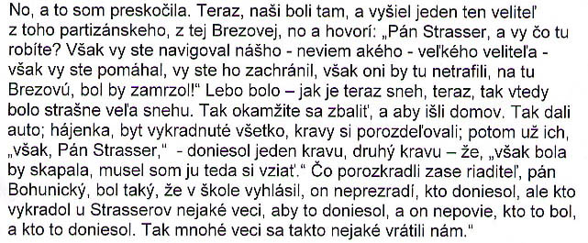

English translation:
"So, then the war ended. School ended. I finished the fourth grade in the town school [middle+high combined] in Zilina, quite successfully, and I came home, and it came about that Germans would be…whoever was in that party…would be evacuated, right? So, I learned that…that my family would also be evacuated and I told myself, „I'm not going anywhere,„ and I picked up my things. There was a pilgrimage in Šaštín, Virgin Mary's, and Mr. Péc, my boss, had a sister there, and I said: „Mr. Péc, I'm going to Šaštín for the pilgrimage.„ So I went. She had a tavern, I was waitressing, my godfather came. He was sitting there, and I sat down and told him to go Polamane, that was the forester's house [their house], to watch it because everything would be looted when my family was evacuated! So I told him that, and the pilgrimage ended, they left, and when I said that I didn't want to go back, Mr. Péc had a father, and there was some sort of a farm near Šaštín. And so they sent a carriage, and drove me to the farm in the carriage. I got there, they hid me there at the farm. I got there, there was Mr. Péc's father, an old gentleman, and a young assistant clerk, a blond boy. We didn't discuss anything, they didn't talk with me about anything. We just played the Joker, or cards, or whatever I would have known how to play we played. Then I slept, one day, then of course another night, and another night passed, and they were saying that, like, that I had to go back to Šaštín. I guess there must have been an alert that I was missing, and Mr. Péc, my boss, was having problems because he said he had no idea where I was! But he did know, I mean, but said that he didn't.

My family was evacuated, they transported them to Trnava to the National Committee [headquarters]. They put them in the back yard, and, my mother had…I was the oldest one, seventeen, [my] brother sixteen, Lidka fif…fourteen-thirteen, and a little baby, Johnny, they had. A brother; brother was born in September, he was one month old! So they slept there in the back yard, I don't know what they gave them there, what blankets, and that's where all the resistance fighters and generals and all those were… So, before, when we were still at the forester's house, there was a snowstorm, it was a harsh winter in the 1944 -going on 1945 - and, well, I, as a girl, and my mother, were sitting, it was night already; [my] father had come home, gone to bed, and suddenly stomping outside, and someone came. A gorgeously dressed, handsome colonel - I don't know anymore whether he was a Russian or what - but there was snow…and he was very…excellently dressed in those clothes, those coats, and all that, and he came, and said that he needed to get to Brezova pod Bradlom. That's where the resistance fighters had their headquarters. And [my] mother is like, „Oh, that's far from here!„ And [my] father, when he heard it, gets up, and says, „I'll take you there.„ Well, [my] mother and I remained petrified, because it had happened that two foresters were killed by these phony resistance fighters. One forester, then another forester… And so, when my father got up to go, my mother froze. And he got dressed and went, and took that gentleman - today I would have asked him whether there were more of them, I'm sure he wasn't alone - and he took him to a certain path and he said, „This one doesn't fork anymore, this one will take you all the way to Brezova pod Bradlom.„ Father knew all those mountains. And then, suddenly, there was stomping outside - and he had come back [home.] Mother relaxed. Me too, and then at last we went to sleep.

So, I've made a jump. Now, my family was there [at the National Committee headquarters], and one general came from the resistance fighters, from Brezova, and said, „Mr. Strasser, what are you doing here? You had directed our - I don't know what - big general - you were helping, you'd saved him. He wouldn't have found Brezova, he would have frozen! Because it was - like there's snow now, now, so it was then that there was so much snow. So [they] immediately [told them] to pack, and they went home. They provided a car. The foresters' house, apartment, all looted.; They [the villagers] had divided the cows among themselves. Then they would say, „but, Mr. Strasser„ - one would bring a cow, another one would bring another cow . „Iit would have starved, I had to take it!„ What they had looted. Then again the headmaster, Mr. Bohunicky, he announced at school that he would not reveal who had brought what, but that whoever stole anything from the Strassers should bring it in, and he wouldn't say who it was and who had brought it. And so that's how we got a few things back."

About Language by Country: The Language by Country videos and other materials were produced by the Five College Center for the Study of World Languages between 1999 - 2003 with funding from the National Security Education Program (NSEP) and the Fund for the Improvement of Postsecondary Education (FIPSE) of the U.S. Department of Education. The videos were filmed by Five College international students in their home countries. The goal was to provide examples of authentic language spoken in its natural cultural environment so that students of all ages can better understand the interplay between a language and its culture. We have tried to remain true to the language our subjects actually uttered. Therefore, we have not corrected grammatical errors and the videos sometimes show highly colloquial language, local slang, and regionally specific speech patterns. At times, we have noted the preferred or more standard forms in parentheses. Most of the transcripts and translations were prepared by the same students who filmed the video, although in some cases the transcripts have also been edited by a language expert.
© 2003 Five College Center for the Study of World Languages and Five Colleges, Incorporated

