Slovak in Slovakia Video Transcripts
Language by Country Collection on LangMedia
http://langmedia.fivecolleges.edu/

"The Year 1938"

Slovak transcript:
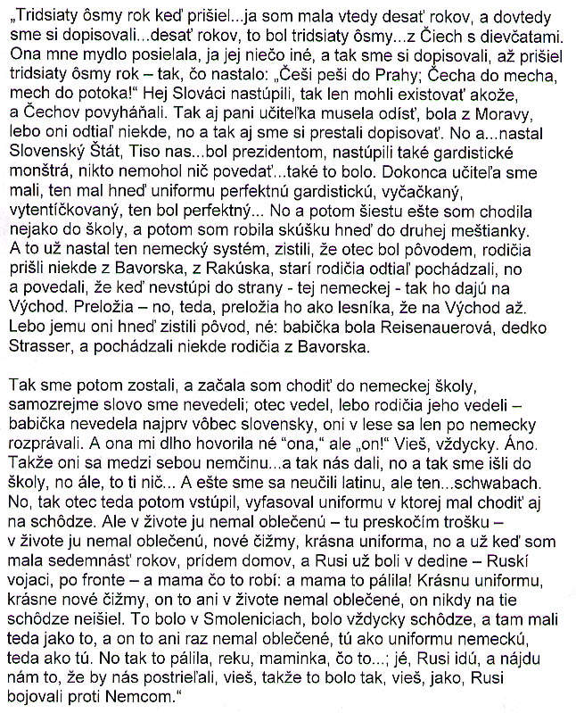

English translation:
"When the year 1938 came…I was ten at that time, and until then we were corresponding…ten years old, that was year 1938…with girls from the Czech Republic. She would send me a bar of soap, I would send her something else, and so we were corresponding until the year 1938 came, and what happened: „Czechs walk back to Prague; a Czech into a sack, the sack into a stream!„ Slovak chauvinists came to power, so it was as if only they could exist, and they forced the Czechs out. So our teacher also had to leave, she was from Moravia, because that's where they [her family] [came] from, and so we also stopped corresponding then. And so…the Slovak State was established. Tiso came to…was the president, Gardist machinery came to power. Nobody could say anything...that's how it was. We even had a teacher, he came in this perfect Gardist uniform, all beribboned, all fluffed up, he was excellent. And so for the sixth grade I was still going to school, I believe, and then I was taking an entrance examination to directly enter the second grade of the town school [middle+high combined]. But that's when the German system had already come into in effect. They found out that [my] father was originally, [his] parents came somewhere from Bavaria and Austria, that's where [my] grandparents came from, and they said that if he didn't join the party - the German one - that they would move him to the East. In other words, transfer him, transfer him as a forester to the East [of Slovakia]. Because they immediately found out his origins, right; [my] grandmother was a Reisenauer, my grandfather a Strasser, and [their] parents came somewhere from Bavaria.

So we stayed and I started to go to a German school, and of course we [she and her siblings] didn't know a word [in German]. My father did because his parents did. At first, my grandmother didn't know any Slovak; they only talked German in the forest. For a long time she didn't call me „she,„ but„he!„ You know, always. Really. So they [talked] in German among themselves...and they put us..we went to school, but it didn't... And we didn't learn the Latin alphabet yet, but the...Schwabach. And so then, my father then joined [the party]. He received this uniform that he was supposed to wear to the meetings. But he didn't wear it once - I'll jump a little here - he didn't wear it once, brand new boots, gorgeous uniform, and when I was already seventeen, I came home and the Russians were already in the village - Russian soldiers, after the war [1945] - and what was my mother doing? My mother was burning it! A gorgeous uniform, gorgeous new boots, he'd never worn it once, he'd never gone to those meetings. The meetings were always in Smoleniece, that's where they had the thing, and he'd never worn it once, the German uniform, I mean. So she was burning it, and I said, „mom, what are you [doing]„; [and she's like] „the Russians are coming, they'll find it.„ They would shoot us, you know, that's how it was, you know, how the Russians were fighting against the Germans."

About Language by Country: The Language by Country videos and other materials were produced by the Five College Center for the Study of World Languages between 1999 - 2003 with funding from the National Security Education Program (NSEP) and the Fund for the Improvement of Postsecondary Education (FIPSE) of the U.S. Department of Education. The videos were filmed by Five College international students in their home countries. The goal was to provide examples of authentic language spoken in its natural cultural environment so that students of all ages can better understand the interplay between a language and its culture. We have tried to remain true to the language our subjects actually uttered. Therefore, we have not corrected grammatical errors and the videos sometimes show highly colloquial language, local slang, and regionally specific speech patterns. At times, we have noted the preferred or more standard forms in parentheses. Most of the transcripts and translations were prepared by the same students who filmed the video, although in some cases the transcripts have also been edited by a language expert.
© 2003 Five College Center for the Study of World Languages and Five Colleges, Incorporated

