Slovak in Slovakia Video Transcripts
Language by Country Collection on LangMedia
http://langmedia.fivecolleges.edu/

"At a Bookstore"

Slovak transcript:
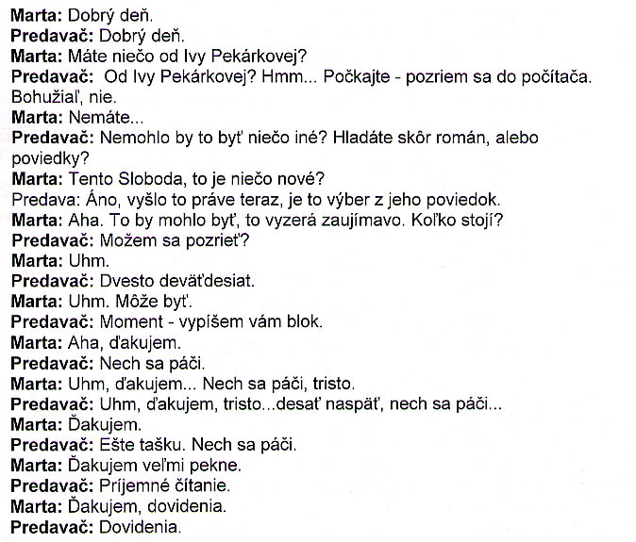

English translation:
"Marta: Hello.
Store assistant: Hello.
Marta: Do you have anything by Iva Pekárková?*
Store assistant: By Iva Pekárková? Hmm... Let me look in the computer. Unfortunately, not.
Marta: You don't...
Store assistant: Couldn't it be something else? Are you looking for a novel or short stories?
Marta: This Sloboda**, is that something new?
Store assistant: Yes, it just came out; it's a selection of his short stories.
Marta: I see. That might do, it looks interesting. How much is it?
Store assistant: Can I have a look?
Marta: Uhm.
Store assistant: Two hundred and ninety.
Marta: Uhm. That's fine.
Store assistant: Just a second - I'll write you a sales receipt.
Marta: Okay, thank you.
Store assistant: Here you are.
Marta: Uhm, thank you... Here you are, three hundred...
Store assistant: Uhm, thank you, three hundred...ten back, here you are.
Marta: Thank you.
Store assistant: Let me give you a bag. Here you go.
Marta: Thank you very much.
Store assistant: Have a pleasant read.
Marta: Thanks, bye.
Store assistant: Bye.
* Iva Pekárková is a prominent contemporary Czech author
**Rudolf Sloboda is a prominent contemporary Slovak author"

About Language by Country: The Language by Country videos and other materials were produced by the Five College Center for the Study of World Languages between 1999 - 2003 with funding from the National Security Education Program (NSEP) and the Fund for the Improvement of Postsecondary Education (FIPSE) of the U.S. Department of Education. The videos were filmed by Five College international students in their home countries. The goal was to provide examples of authentic language spoken in its natural cultural environment so that students of all ages can better understand the interplay between a language and its culture. We have tried to remain true to the language our subjects actually uttered. Therefore, we have not corrected grammatical errors and the videos sometimes show highly colloquial language, local slang, and regionally specific speech patterns. At times, we have noted the preferred or more standard forms in parentheses. Most of the transcripts and translations were prepared by the same students who filmed the video, although in some cases the transcripts have also been edited by a language expert.
© 2003 Five College Center for the Study of World Languages and Five Colleges, Incorporated

