Slovak in Slovakia Video Transcripts
Language by Country Collection on LangMedia
http://langmedia.fivecolleges.edu/

"A Movie Discussion"

Slovak transcript:
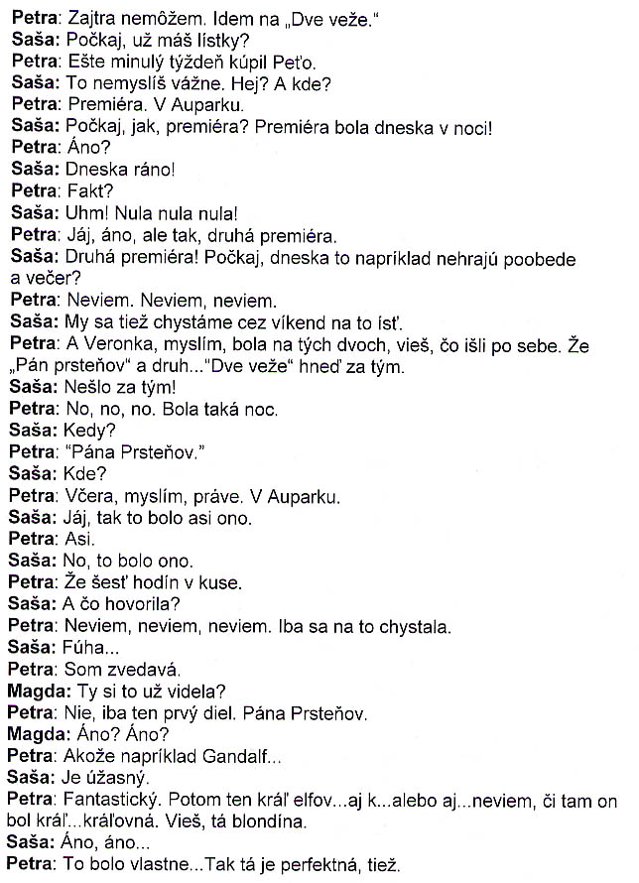
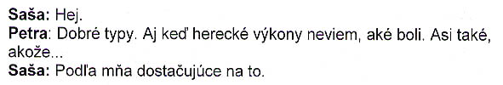

English translation:
"Petra: Tomorrow I can't. I'm going to see „Two Towers.„
Saša: Wait, do you have tickets?
Petra: Pete already got them last week.
Saša: You're kidding. Really? Where?
Petra: For opening night. In Aupark.
Saša: Wait, how? Opening night? Opening night was last night!
Petra: Really?
Saša: This morning!
Petra: Seriously?
Saša: Yeah! Zero zero zero!
Petra: Oh, okay. So, the second opening night, then.
Saša: Second opening night! Wait, for instance, aren't they playing it today in the afternoon or evening?
Petra: I don't know. I don't know. I don't know.
Saša: We're also planning to go see it over the weekend.
Petra: And Veronka, I think, went to see the two of them, you know, that went one after the other. Like, Lord of the Rings and sec... Two Towers right after.
Saša: It didn't go right after!
Petra: Yeah, yeah yeah. There was such a night.
Saša: When?
Petra: For Lord of the Rings.
Saša: Where?
Petra: Last night, I think, in Aupark.
Saša: Oh, okay, so that was what is was.
Petra: I guess.
Saša: Right, that was what it was.
Petra: Like, six hours straight.
Saša: And what did she say?
Petra: I don't know, I don't know, I don't know. She was just planning to go.
Saša: Wow.
Petra: I'm curious.
Magda: You've already seen it?
Petra: No, just the first episode. „Lord of the Rings.„
Magda: Really? Really?
Petra: I mean, for example Gandalf...
Saša: Was amazing.
Petra: Awesome. Then the king of the elves...or also...I don't know if he was a king...the queen. You know, the blond one.
Saša: Yes, yes.
Petra: That was like... She was excellent, too.
Saša: Yeah.
Petra: Good casting. Although the acting I'm not sure about. Like...
Saša: I think it was sufficient."

About Language by Country: The Language by Country videos and other materials were produced by the Five College Center for the Study of World Languages between 1999 - 2003 with funding from the National Security Education Program (NSEP) and the Fund for the Improvement of Postsecondary Education (FIPSE) of the U.S. Department of Education. The videos were filmed by Five College international students in their home countries. The goal was to provide examples of authentic language spoken in its natural cultural environment so that students of all ages can better understand the interplay between a language and its culture. We have tried to remain true to the language our subjects actually uttered. Therefore, we have not corrected grammatical errors and the videos sometimes show highly colloquial language, local slang, and regionally specific speech patterns. At times, we have noted the preferred or more standard forms in parentheses. Most of the transcripts and translations were prepared by the same students who filmed the video, although in some cases the transcripts have also been edited by a language expert.
© 2003 Five College Center for the Study of World Languages and Five Colleges, Incorporated

