Romanian in Romania Video Transcripts
Language by Country Collection on LangMedia
http://langmedia.fivecolleges.edu/

"Making a Dental Appointment"

Romanian transcript:
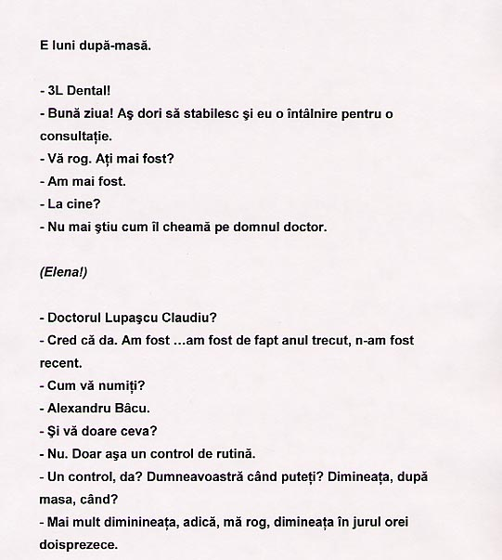
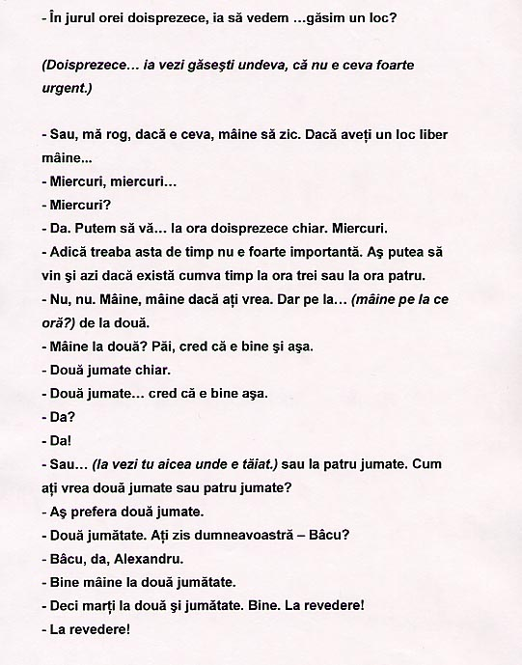

English translation:
"Note: The italics between the parentheses were addressed to a third person working in the office.
It's Monday afternoon.
- 3L Dental!
- Hi! I want to schedule an appointment.
- Please. Have you been here before?
- Yes I have.
- Who saw you?
- I don't remember the name of the doctor.
(Elena)
- Doctor Lupascu Claudiu?
Note: in Romania people would usually introduce themselves by saying the last name first and then the first name - Lupascu (last name), Claudiu (first name)
- I think so. I was… In fact I was there last year, not recently.
- What is your name?
- Alexandru Bâcu.
- And does anything hurt?
- No. It's just a routine check.
- A check? When can you make it? In the morning, in the afternoon, when?
- I would rather do it in the morning. Oh well, I mean in the morning around twelve o'clock.
- Around twelve o'clock. Let's see… can we find an opening?
(Twelve… take a look and see if you can find something, it's not an emergency)
- Oh, if there's a problem, let's say tomorrow. If you have an opening tomorrow…
- Wednesday, Wednesday…
- Wednesday?
- Yes. We can… twelve o'clock even. Wednesday.
- I mean this whole time business is not really important for me. I will come today, if that's possible, around three o'clock or four.
- No, no. Tomorrow, tomorrow if you want. But …( what time tomorrow?) at two.
- Tomorrow at two. Well, I guess it's okay then.
- Half past two even.
- Half past two? I guess it's okay.
- All right? (lit: yes?)
- All right! (lit: yes!)
- Or …( take a look here where it's crossed) or at half past four. What would you prefer half past two or half past four?
- I would prefer half past two.
- Half past two. You said - Bâcu?
- Bâcu, yes, Alexandru.
Note: again last name first and then the first name.
- OK. Tomorrow at half past two.
- So Tuesday at half past two. Okay. Goodbye!
- Goodbye!"

About Language by Country: The Language by Country videos and other materials were produced by the Five College Center for the Study of World Languages between 1999 - 2003 with funding from the National Security Education Program (NSEP) and the Fund for the Improvement of Postsecondary Education (FIPSE) of the U.S. Department of Education. The videos were filmed by Five College international students in their home countries. The goal was to provide examples of authentic language spoken in its natural cultural environment so that students of all ages can better understand the interplay between a language and its culture. We have tried to remain true to the language our subjects actually uttered. Therefore, we have not corrected grammatical errors and the videos sometimes show highly colloquial language, local slang, and regionally specific speech patterns. At times, we have noted the preferred or more standard forms in parentheses. Most of the transcripts and translations were prepared by the same students who filmed the video, although in some cases the transcripts have also been edited by a language expert.
© 2003 Five College Center for the Study of World Languages and Five Colleges, Incorporated

