Japanese in Japan Video Transcripts
Language by Country Collection on LangMedia
http://langmedia.fivecolleges.edu/

"Savings Accounts at the Post Office"

Japanese transcript:
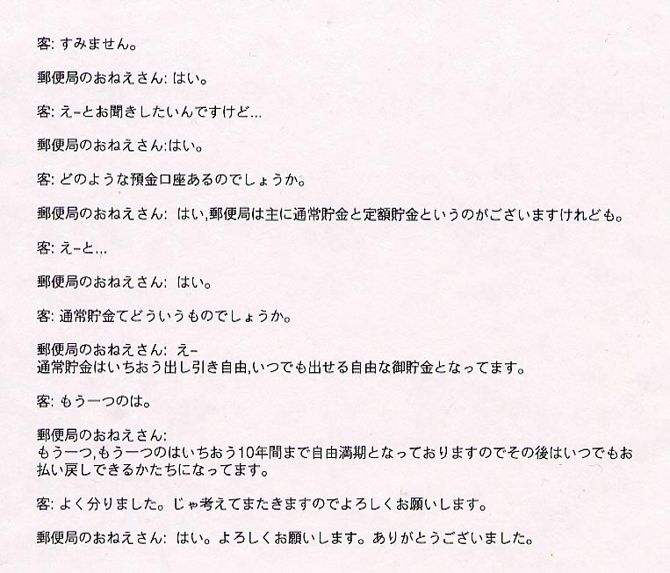

English translation:
"Customer: Excuse me.
Postal Clerk: Yes?
Customer: I was wondering…
Postal Clerk: Yes?
Customer: What kind of saving accounts do you have?
Postal Clerk: Post offices have normal accounts as well as certificate of deposit accounts.
Customer: How does the normal account work?
Postal Clerk: Um...with normal accounts you can take money out whenever you want to, and in that way (it) is a very flexible account.
Customer: How about the other one?
Postal Clerk: The other…with the other one, you cannot withdraw money for 10 years. After that, you are free to withdraw money at any time.
Customer: That makes a lot of sense. I am going to think about it and then come back. I look forward to coming here again. ( This means, lliterally, „I submit myself to you.„)
Postal Clerk: Sure. We look forward to seeing you (This means, literally, „I submit myself to you.„). Thank you very much."

About Language by Country: The Language by Country videos and other materials were produced by the Five College Center for the Study of World Languages between 1999 - 2003 with funding from the National Security Education Program (NSEP) and the Fund for the Improvement of Postsecondary Education (FIPSE) of the U.S. Department of Education. The videos were filmed by Five College international students in their home countries. The goal was to provide examples of authentic language spoken in its natural cultural environment so that students of all ages can better understand the interplay between a language and its culture. We have tried to remain true to the language our subjects actually uttered. Therefore, we have not corrected grammatical errors and the videos sometimes show highly colloquial language, local slang, and regionally specific speech patterns. At times, we have noted the preferred or more standard forms in parentheses. Most of the transcripts and translations were prepared by the same students who filmed the video, although in some cases the transcripts have also been edited by a language expert.
© 2003 Five College Center for the Study of World Languages and Five Colleges, Incorporated

