Japanese in Japan Video Transcripts
Language by Country Collection on LangMedia
http://langmedia.fivecolleges.edu/

"Renting a Car"

Japanese transcript:
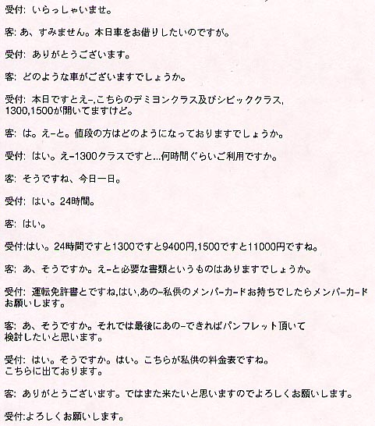

English translation:
"Desk Clerk: Welcome.
Yamada: Excuse me, I would like to rent a car.
Desk Clerk: Thank you very much.
Yamada: What kind of car can I rent?
Desk Clerk: Today, we have the Demiyon and the Civic, 1300 and 1500.
Yamada: Okay. What are the prices like?
Desk Clerk: Well, if it's the 1300 ...how long do you plan to use it?
Yamada: Let's see...the whole day today.
Desk Clerk: Okay. 24 hours?
Yamada: Yes.
Desk Clerk: For 24 hours, it would be 9400 yen for the 1300 and 11000 yen for the 1500.
Yamada: Oh, I see. Um...are there any documents I need?
Desk Clerk: You would need a driver's license and if you have one, our member's card, as well.
Yamada: Oh, okay. And, can I get one of your brochures for information?
Desk Clerk: Yes, sure, yes. This is our price list. It is right here.
Yamada: Thank you very much. I would like to come again, so I will see you then.
Desk Clerk: See you then."

About Language by Country: The Language by Country videos and other materials were produced by the Five College Center for the Study of World Languages between 1999 - 2003 with funding from the National Security Education Program (NSEP) and the Fund for the Improvement of Postsecondary Education (FIPSE) of the U.S. Department of Education. The videos were filmed by Five College international students in their home countries. The goal was to provide examples of authentic language spoken in its natural cultural environment so that students of all ages can better understand the interplay between a language and its culture. We have tried to remain true to the language our subjects actually uttered. Therefore, we have not corrected grammatical errors and the videos sometimes show highly colloquial language, local slang, and regionally specific speech patterns. At times, we have noted the preferred or more standard forms in parentheses. Most of the transcripts and translations were prepared by the same students who filmed the video, although in some cases the transcripts have also been edited by a language expert.
© 2003 Five College Center for the Study of World Languages and Five Colleges, Incorporated

