Greek in Greece Video Transcripts
Language by Country Collection on LangMedia
http://langmedia.fivecolleges.edu/

"Inquiring About Flights"

Greek transcript:
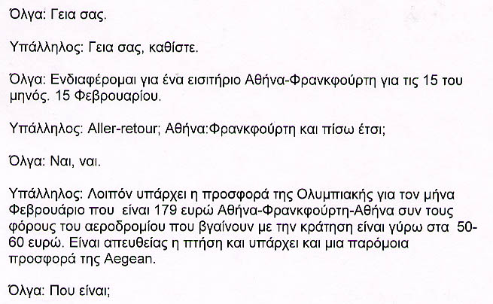
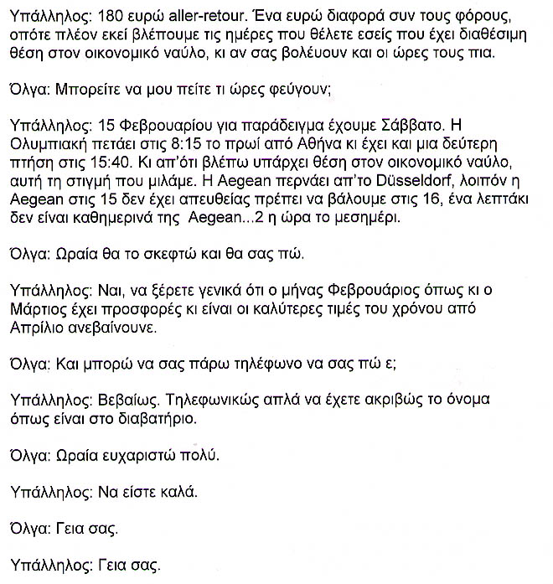

English translation:
"Olga: Hi.
Employee: Hi, have a seat.
Olga: I'm interested in a ticket from Athens to Frankfurt for the fifteenth of this month. The fifteenth of February.
Employee: Round trip? Athens to Frankfurt and back, right?
Olga: Yes, yes.
Employee: Ok, there's an Olympics offer for the month of February which is 179 euros Athens-Frankfurt-Athens plus the airport taxes that come with the reservations, which are 50-60 euros. It's a direct flight, and there's a similar offer from Aegean.
Olga: Which is?
Employee: 180 euros round trip. One euro difference plus the taxes; so we will look at the dates you want, where there are available seats in economy class, and if the hours suit you.
Olga: Can you tell me what times they leave?
Employee: For example, the fifteenth of February is Saturday. Olympic Airlines flies at 8:15 in the morning from Athens, and there's a second flight at 3:40 p.m. And from what I see, there is an available seat in the economy class. As we speak. Aegean passes through Düsseldorf. Okay, Aegean doesn't have a direct flight on the fifteenth; we have to try the sixteenth, one minute; Aegean flights don't run daily...2 o'clock in the afternoon.
Olga: Okay, I'll think about it and tell you.
Employee: Good, just so you know, February as well as March are months with deals and offers and they are the best prices of the year. From April on, they start increasing.
Olga: Can I call you and tell you?
Employee: Certainly over the phone, but you must have your name exactly the way it is written in your passport.
Olga: Okay, thank you very much.
Employee: God bless you.
Olga: Bye.
Employee: Bye."

About Language by Country: The Language by Country videos and other materials were produced by the Five College Center for the Study of World Languages between 1999 - 2003 with funding from the National Security Education Program (NSEP) and the Fund for the Improvement of Postsecondary Education (FIPSE) of the U.S. Department of Education. The videos were filmed by Five College international students in their home countries. The goal was to provide examples of authentic language spoken in its natural cultural environment so that students of all ages can better understand the interplay between a language and its culture. We have tried to remain true to the language our subjects actually uttered. Therefore, we have not corrected grammatical errors and the videos sometimes show highly colloquial language, local slang, and regionally specific speech patterns. At times, we have noted the preferred or more standard forms in parentheses. Most of the transcripts and translations were prepared by the same students who filmed the video, although in some cases the transcripts have also been edited by a language expert.
© 2003 Five College Center for the Study of World Languages and Five Colleges, Incorporated

