Bangla in Bangladesh Video Transcripts
Language by Country Collection on LangMedia
http://langmedia.fivecolleges.edu/

"An ATM"

Bangla transcript:
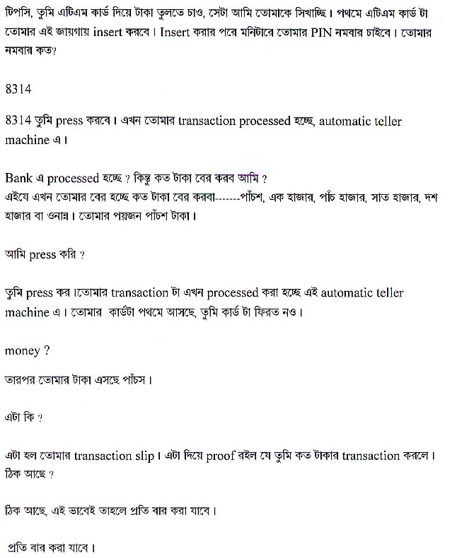

English translation:
"--Tipsy, now I will show you how to withdraw money using an ATM card. First, you will insert the ATM card here, and after that they will ask for your PIN number on the monitor. What is your PIN number?
--8314
--Press 8314, now your transaction is being processed in the automatic teller machine.
--It’s being processed in the bank? But how much money do I take out?
--Here, now they are showing you how much money you can withdraw ---500, 1,000, 5,000, 7,000, 10,000, or some other amount. You need 500 Taka.
--Can I press down?
--Yes, press down. Your transaction is now being processed in this automatic teller machine. First, your card is being returned.
--Money?
--Then here comes your 500 Taka.
--What is this?
--This is your transaction slip. This is proof of the amount of the transaction. Okay?
--Okay. So this is how I do it every time.
--Yes, every time."

About Language by Country: The Language by Country videos and other materials were produced by the Five College Center for the Study of World Languages between 1999 - 2003 with funding from the National Security Education Program (NSEP) and the Fund for the Improvement of Postsecondary Education (FIPSE) of the U.S. Department of Education. The videos were filmed by Five College international students in their home countries. The goal was to provide examples of authentic language spoken in its natural cultural environment so that students of all ages can better understand the interplay between a language and its culture. We have tried to remain true to the language our subjects actually uttered. Therefore, we have not corrected grammatical errors and the videos sometimes show highly colloquial language, local slang, and regionally specific speech patterns. At times, we have noted the preferred or more standard forms in parentheses. Most of the transcripts and translations were prepared by the same students who filmed the video, although in some cases the transcripts have also been edited by a language expert.
© 2003 Five College Center for the Study of World Languages and Five Colleges, Incorporated

