Urdu in Pakistan Video Transcripts
Language by Country Collection on LangMedia
http://langmedia.fivecolleges.edu/

"Renting a Car"

Urdu transcript:
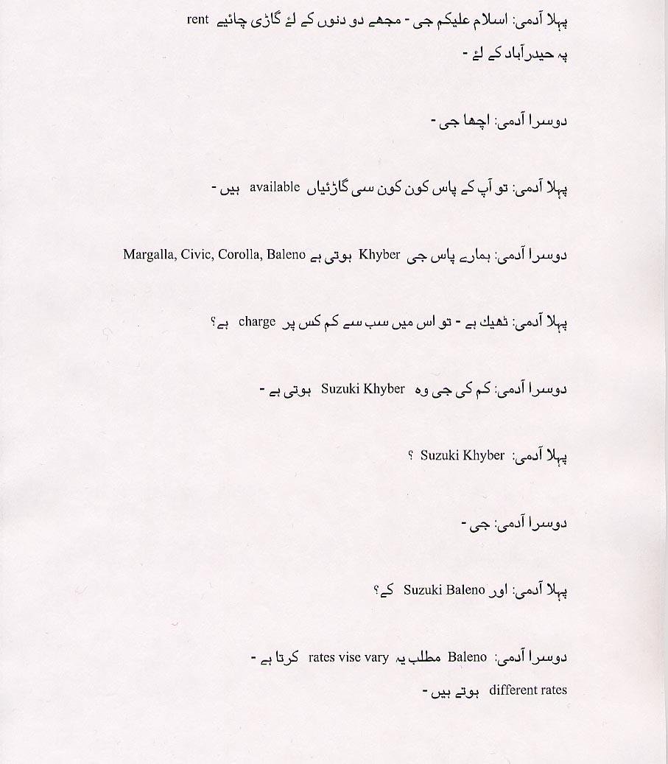
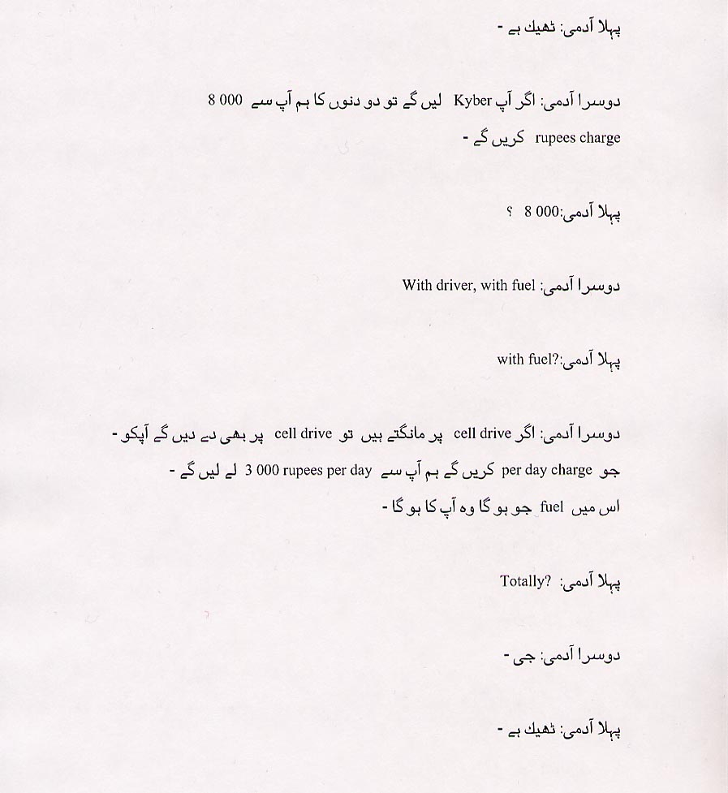
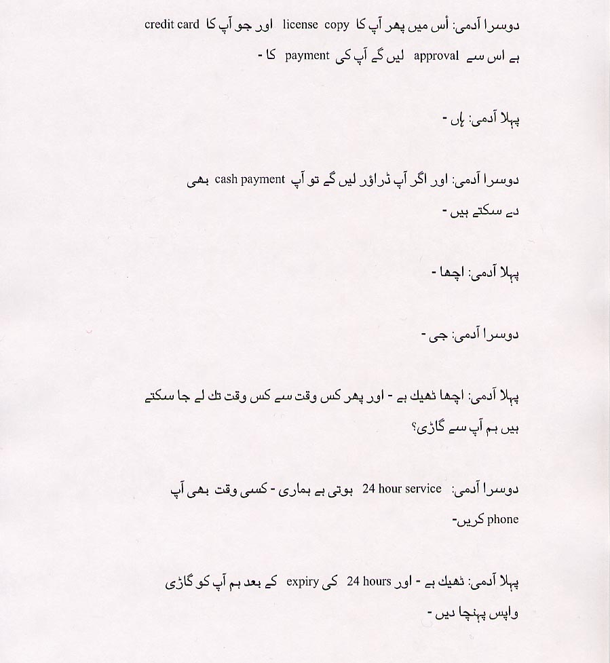
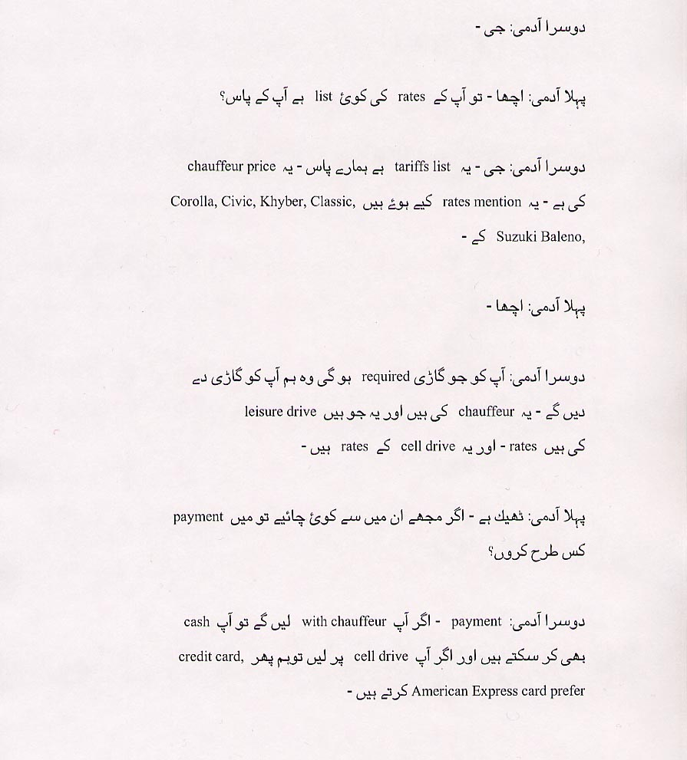
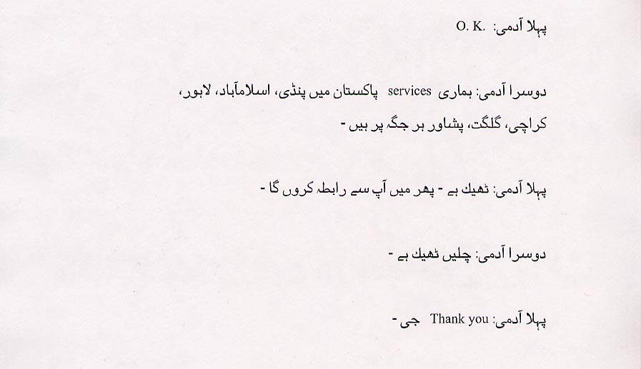

English translation:
"NOTE: Many speakers add the suffix 'na' to the end of their words as a habit of speech. This is similar to an English speaker frequently using 'like' or 'umm' in speech.
First Man: As-salam-alaikum (common Muslim Greeting). I want to rent a car for
two days to go to Hyderabad.
Second Man: Yes (polite).
First Man: So what sort of cars do you have?
Second Man: We have Khyber, Margalla, Civic, Corrolla, Baleno.
First Man: Right. So which one is the cheapest to rent?
Second Man: The cheapest. That's the Suzuki Khyber.
First Man: Suzuki Khyber?
Second Man: Yes.
First Man: And the Suzuki Baleno?
Second Man: Baleno. That depends on the rates. We have different rates.
First Man: O.K.
Second Man: If you rent a Khyber, then for two days we'll charge you 8 000 rupees.
First Man: 8 000?
Second Man: With driver, with fuel.
First Man: With fuel?
Second Man: If you want it on 'cell drive', we can give you on 'cell drive' too. The per day
charge will be 3 000 rupees. For this, you have to provide the fuel.
First Man: Totally?
Second Man: Yes.
First Man: O.K.
Second Man: For this we'll need a copy of your license and approval of the payment from your credit card company.

First Man: Right.
Second Man: But if you hire a chauffeur as well, you can pay in cash.
First Man: Right.
Second Man. Yes.
First Man: Alright. And when can I come to pick up a car?
Second Man: We have 24 hour service. You can call us at any time.
First Man: Right, and the car should be returned after 24 hours?
Second Man: Yes.
First Man: Right. Do you have a list of your rates?
Second Man: Yes. Here is a list of our tariffs. This is the list that includes the
cost of a chauffeur. These are the rates for Khyber, Classic, Suzuki Baleno, Corolla,
and Civic.
First Man. Right.
Second Man: We can rent you any car you want. These include the price of a
chauffeur. Those are the rates for 'leisure drive' and these are for 'cell drive'.
First Man: Right. If I want to rent a car how do I pay for it?
Second Man: To pay for it, if you are hiring a chauffeur you can pay in cash or if
you are taking it out on 'cell drive' then we need a credit card. We prefer American Express.
First Man: O. K.
Second Man: In Pakistan, we offer services in most places: 'Pindi, Islamabad, Lahore, Karachi, Gilgit, Peshawar.
First Man: Alright. I'll get in touch with you.
Second Man: Alright. That sounds good.
First Man: Thank you (polite).
NOTE: Many speakers add the suffix 'na' to the end of their words as a habit of speech. This is similar to an English speaker frequently using 'like' or 'umm' in speech."

About Language by Country: The Language by Country videos and other materials were produced by the Five College Center for the Study of World Languages between 1999 - 2003 with funding from the National Security Education Program (NSEP) and the Fund for the Improvement of Postsecondary Education (FIPSE) of the U.S. Department of Education. The videos were filmed by Five College international students in their home countries. The goal was to provide examples of authentic language spoken in its natural cultural environment so that students of all ages can better understand the interplay between a language and its culture. We have tried to remain true to the language our subjects actually uttered. Therefore, we have not corrected grammatical errors and the videos sometimes show highly colloquial language, local slang, and regionally specific speech patterns. At times, we have noted the preferred or more standard forms in parentheses. Most of the transcripts and translations were prepared by the same students who filmed the video, although in some cases the transcripts have also been edited by a language expert.
© 2003 Five College Center for the Study of World Languages and Five Colleges, Incorporated

