Turkish in Turkey Video Transcripts
Language by Country Collection on LangMedia
http://langmedia.fivecolleges.edu/

"Bargaining for a Tablecloth"

Turkish transcript:
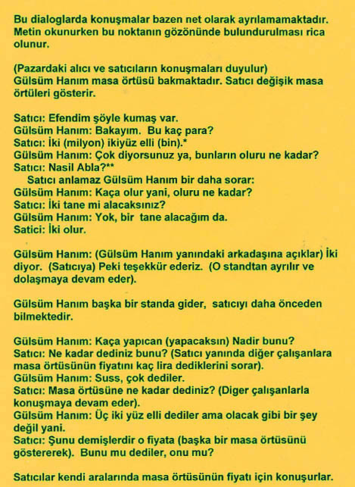
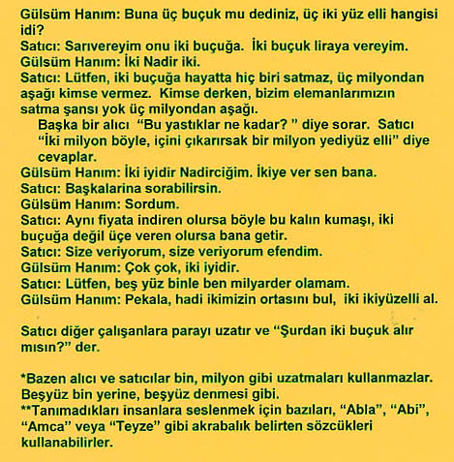

English translation:
"In these dialogues the speakers sometimes talk at the same time. Please consider this point while following the text.
(We hear salesmen and customers talking at the open Bazaar.)
Mrs. Gülsüm is looking for a tablecloth. At the first stand, the salesman is showing her different tablecloths.
Salesman: There is this fabric.
The woman: Let me look. How much is it?
Salesman: Two, two hundred fifty (He means two million and two hundred fifty Turkish liras)
The woman: You are saying a very high price, what is the least possible price (can it be a little cheaper?)?
(The Salesman did not understand, and the woman repeats the question again.)
The woman: How much can you reduce that price?
Salesman: Will you buy two?
The woman: No, I'll buy one.
Salesman: It could be two (he means two million Turkish liras).

The woman: (She tells the price to her friend) He says two. (to the Salesman) Okay, thanks.
(She leaves that stand and looks for a tablecloth at the other stands).
The woman goes to another stand; she already knows the salesman.
The woman: How much will you ask for this one, Nadir?
Salesman: How much did you say for this one? (He asks the other salesmen at the stand what price they ask for the tablecloth).
The woman: Sisssshhhh, they asked a lot.
Salesman: How much did you ask for the table cloth? (He continues to speak with the other salesmen.)
The woman: Three [million] two hundred fifty they said, but this is impossible.
Salesman: They meant this one for that price (He shows another tablecloth). Which one did they mention, this one or that one?
(The salesmen speak about the price between themselves.)
The woman: He said three and half (OR „three five„ meaning three million and five hundred Turkish liras), which one is three two hundred fifty (three million two hundred and fifty Turkish liras)?
Salesman: I'll wrap that one up for two half (OR „two five„ meaning two million and five hundred), I will give it to you for two and half (OR „two five„ meaning two million and five hundred ).
The woman: Two, Nadir, two (she means two million Turkish liras)
Salesman: Please, nobody can sell this for two and half, nobody can give this for under three million. When I say nobody, any of our staff-salesmen can not sell this under three million.

Another customers asks „how much are these pillows?„
Salesman replies „Two million like this, if we take out the inside-filling it is one million seven hundred fifty.„
The woman: Two is good, my dear Nadir (the name of the salesman). Give it to me for two (she means for two million Turkish liras).
Salesman: You can ask the others.
The woman: I asked.
Salesman: If anybody can give the same price for this thick fabric, not even two and half, for three, bring it back to me.
Salesman: I am giving it to you, I am giving it to you madam. (He means he gives this price only for her).
The woman: It is a lot, it is a lot, two is good.
Salesman: Please, I can not be a millionaire with five hundred.
The woman: Okay, let's compromise, take two two hundred fifty.
Salesman gives the money to another salesman and he says „Take two and half (OR two hundred fifty) from here.„"

About Language by Country: The Language by Country videos and other materials were produced by the Five College Center for the Study of World Languages between 1999 - 2003 with funding from the National Security Education Program (NSEP) and the Fund for the Improvement of Postsecondary Education (FIPSE) of the U.S. Department of Education. The videos were filmed by Five College international students in their home countries. The goal was to provide examples of authentic language spoken in its natural cultural environment so that students of all ages can better understand the interplay between a language and its culture. We have tried to remain true to the language our subjects actually uttered. Therefore, we have not corrected grammatical errors and the videos sometimes show highly colloquial language, local slang, and regionally specific speech patterns. At times, we have noted the preferred or more standard forms in parentheses. Most of the transcripts and translations were prepared by the same students who filmed the video, although in some cases the transcripts have also been edited by a language expert.
© 2003 Five College Center for the Study of World Languages and Five Colleges, Incorporated

