Turkish in Turkey Video Transcripts
Language by Country Collection on LangMedia
http://langmedia.fivecolleges.edu/

"At a Fruit and Vegetable Market"

Turkish transcript:
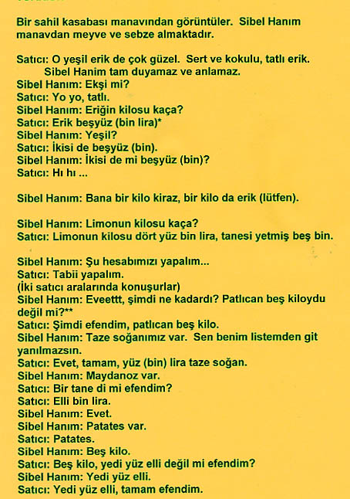
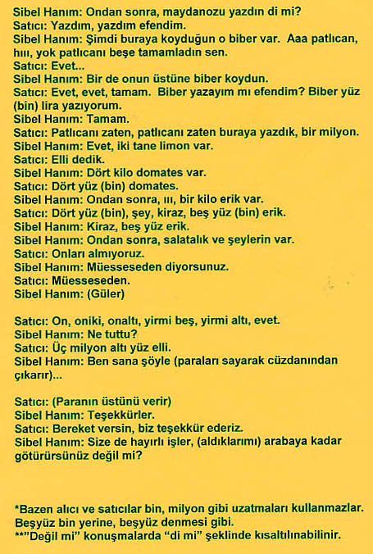

English translation:
"This is a small village „manav„ (a neighborhood store selling fresh vegetables and fruits) in the Western Coastal Region. The woman is buying fruits and vegetables.
Clerk: Those green plums are very delicious; firm and sweet-smelling and sweet.
Woman: Is it sour?
Clerk: No, no, sweet.
Woman: How much is one kilo of plums?
Clerk: Plums are five hundred (thousand).*
Woman: Green?
Clerk: Both of them are five hundred.
Woman: Are both of them five hundred?
Clerk: Uhuh (He means yes).
Woman: One kilo cherry, one kilo plum (for me).
Woman: How much is one kilo of lemons?
Clerk: One kilo of lemons is four hundred thousand, one lemon is seventy five thousand.
Woman: Lets see how much it is.
Clerk: Sure, let's do.
(The two clerks speak between themselves)
Woman: Yes, now how much was it? The eggplant was five kilos, wasn't it?
Clerk: Now, madam, eggplant is five kilos.
Woman: We have fresh onions (scallions). It would be easier if you just follow my list.
Clerk: Yes, okay, one (thousand) lira of fresh onions.
Woman: I have a bunch of parsley.
Clerk: It is one bunch, isn't it madam?
Clerk: Fifty thousand liras.
Woman: Yes.
Woman: There are potatoes.
Clerk: Potatoes.
Woman: Fi,ve kilos.
Clerk: Five kilos, seven hundred and fifty (thousand), isn't it madam?
Woman: Seven hundred fifty.
Clerk: Seven hundred fifty, okay madam.
Woman: After that, did you write down parsley?
Clerk: I wrote it, I wrote it madam.
Woman: Now, there are the peppers you put here. Aaa, eggplant, hiii, no, you rounded off the eggplant to five kilos?
Clerk: Yes.
Woman: You put pepper on it.
Clerk: Yes, yes, okay. Shall I write the pepper, madam? I am writing one (thousand) liras for the peppers.
Woman: Okay.
Clerk: We already wrote eggplant, already wrote eggplant down here, one million.
Woman: Yes, there are two lemons.
Clerk: We said fifty.
Woman: There are four kilos of tomatoes.
Clerk: Four hundred (thousand) for the tomatoes.
Woman: After that, eee, there is one kilo of plums.
Clerk: Four hundred (thousand), cherries, five hundred (thousand) for plums.
Woman: Cherries, five hundred for plums.
Woman: After that, cucumbers and other things.
Clerk: We won't count them.
Woman: It is on the house, as you say.
Clerk: It is on the house.
Woman: (Laughs)
Clerk: Ten, twelve, sixteen, twenty five, twenty six, yes.
Woman: What is the total?
Clerk: Three million six hundred and fifty (thousand).
Woman: I will give . . . (she counts the money and takes it from her purse)
Clerk: (Gives the change)
Woman: Thanks.
Clerk: May you continue to be prosperous, we thank you.
Woman: May your business be prosperous! You could take it to the car, couldn't you?
*Sometimes clerks and customers do not use thousand, million extensions. Instead of five hundred thousand, they use five hundred for example."

About Language by Country: The Language by Country videos and other materials were produced by the Five College Center for the Study of World Languages between 1999 - 2003 with funding from the National Security Education Program (NSEP) and the Fund for the Improvement of Postsecondary Education (FIPSE) of the U.S. Department of Education. The videos were filmed by Five College international students in their home countries. The goal was to provide examples of authentic language spoken in its natural cultural environment so that students of all ages can better understand the interplay between a language and its culture. We have tried to remain true to the language our subjects actually uttered. Therefore, we have not corrected grammatical errors and the videos sometimes show highly colloquial language, local slang, and regionally specific speech patterns. At times, we have noted the preferred or more standard forms in parentheses. Most of the transcripts and translations were prepared by the same students who filmed the video, although in some cases the transcripts have also been edited by a language expert.
© 2003 Five College Center for the Study of World Languages and Five Colleges, Incorporated

