Thai in Thailand Video Transcripts
Language by Country Collection on LangMedia
http://langmedia.fivecolleges.edu/

"A Family Breakfast"

Thai transcript:
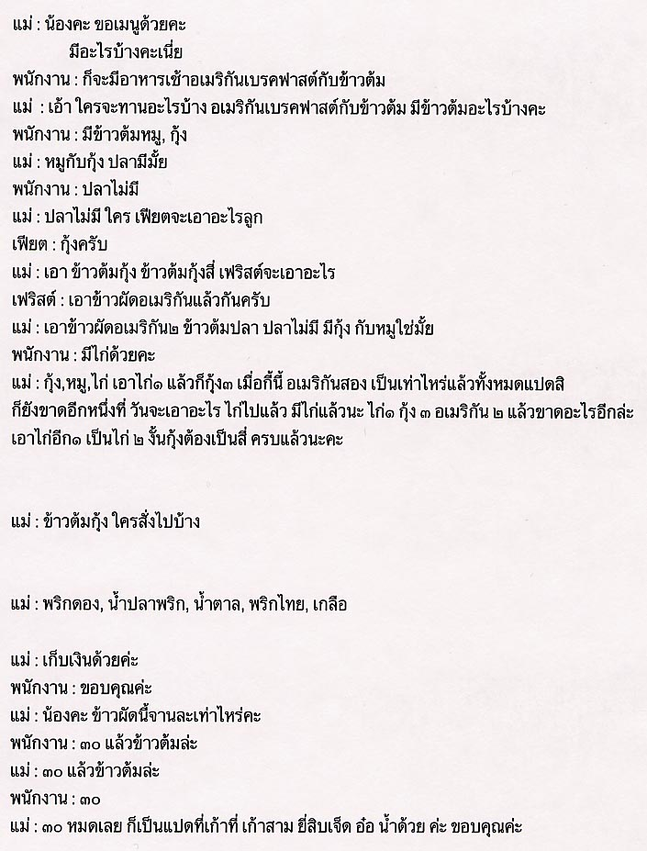

English translation:
"Mother: Can I have the menu? So, What do you have?
The waitress: We have an American breakfast and porridge.
Mother: Okay. What do you guys want? There is an option of an American breakfast and porridge. What kind of porridge do you have?
The waitress: We have pork and shrimp.
Mother: Pork and shrimp. What about fish?
The waitress: No, we don't have any.
Mother: There is no fish? So F1 (the boy's name) what would you like?
The first boy: Shrimp please.
Mother: Four shrimp porridges please. F2 what about you?
The second boy: American fried rice please.
Mother: So may we have two orders of American fried rice? There is no fish porridge, but you have fish and shrimp, right?
The waitress: We also have chicken.
Mother: There is shrimp, pork and chicken. So now we have one chicken, three shrimp porridges and two American fried rice. How many people do we have? Eight right? So we are still missing one. F3 (the girl's name) what would you like? We already have one chicken, three shrimp porridges and two American fried rice. We are missing one so let's have one more chicken and one more shrimp porridge. Then we are all set.
Mother: Who ordered shrimp porridge?
Mother: Vinegar, fish sauce, sugar, pepper, salt.
Mother: Check the bill, please.
Mother: Thank you.
Mother: Excuse me, how much does the American fried rice cost?
The waitress: Thirty baht.
Mother: What about the porridges?
The waitress: Thirty baht for each.
Mother: So everything is thirty baht. There are eight... nine. Nine three times three is twenty-seven, plus water. Okay. Thank you."

About Language by Country: The Language by Country videos and other materials were produced by the Five College Center for the Study of World Languages between 1999 - 2003 with funding from the National Security Education Program (NSEP) and the Fund for the Improvement of Postsecondary Education (FIPSE) of the U.S. Department of Education. The videos were filmed by Five College international students in their home countries. The goal was to provide examples of authentic language spoken in its natural cultural environment so that students of all ages can better understand the interplay between a language and its culture. We have tried to remain true to the language our subjects actually uttered. Therefore, we have not corrected grammatical errors and the videos sometimes show highly colloquial language, local slang, and regionally specific speech patterns. At times, we have noted the preferred or more standard forms in parentheses. Most of the transcripts and translations were prepared by the same students who filmed the video, although in some cases the transcripts have also been edited by a language expert.
© 2003 Five College Center for the Study of World Languages and Five Colleges, Incorporated

