French and Wolof in Senegal Video Transcripts
Language by Country Collection on LangMedia
http://langmedia.fivecolleges.edu/

"Buying Stamps at the Post Office"

Wolof transcript:
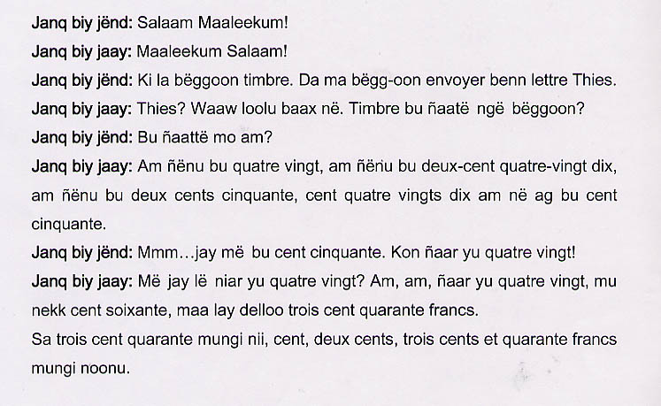

English translation:
"Buyer: Greetings!
Seller: Greetings!
Buyer: I want some stamps. I'd like to send a letter to Thies.
Seller: Thies? All right, a stamp of how many francs would you like?
Buyer: Which ones do you have?
Seller: We have some for eighty francs, some for two hundred and ninety francs, some for one hundred and fifty francs, some for ninety francs and others for a hundred and fifty francs!
Buyer: Ok, I will take the one for a hundred and fifty. Actually two of eighty-francs.
Seller: So you want two of the eighty francs. Here, two, eighty francs. That comes to a hundred and sixty. Your change is three hundred and forty francs.
Here are your three hundred and forty francs, one hundred, two hundred, three hundred and forty francs."

About Language by Country: The Language by Country videos and other materials were produced by the Five College Center for the Study of World Languages between 1999 - 2003 with funding from the National Security Education Program (NSEP) and the Fund for the Improvement of Postsecondary Education (FIPSE) of the U.S. Department of Education. The videos were filmed by Five College international students in their home countries. The goal was to provide examples of authentic language spoken in its natural cultural environment so that students of all ages can better understand the interplay between a language and its culture. We have tried to remain true to the language our subjects actually uttered. Therefore, we have not corrected grammatical errors and the videos sometimes show highly colloquial language, local slang, and regionally specific speech patterns. At times, we have noted the preferred or more standard forms in parentheses. Most of the transcripts and translations were prepared by the same students who filmed the video, although in some cases the transcripts have also been edited by a language expert.
© 2003 Five College Center for the Study of World Languages and Five Colleges, Incorporated

