French and Wolof in Senegal Video Transcripts
Language by Country Collection on LangMedia
http://langmedia.fivecolleges.edu/

"What is the Number for Directory Assistance?"

Wolof transcript:
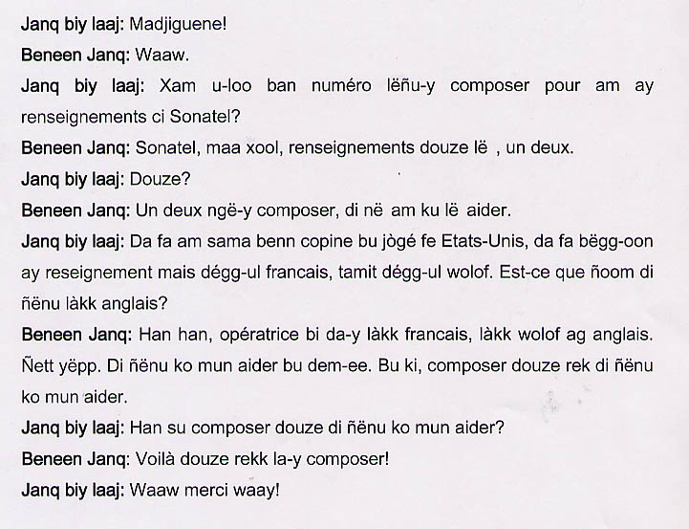

English translation:
"Young woman asking: Madjiguene!
Other young woman: Yes!
Young woman asking: Would you happen to know the number to dial for directory assistance at Sonatel?
Other young woman: At Sonatel? Let me see…directory assistance is twelve.
Young woman asking: Twelve?
Other young woman: Yes, you dial one, two and someone will help you.
Young woman asking: I have a friend who came from the United States, and she would like to get some information. The problem is that she doesn't speak French or Wolof, only English. Does the operator speak English?
Other young woman: Yes, the operator speaks French, Wolof and English, all three of them. She will get help when she dials that number.
Young woman asking: Okay, so if she dials twelve she will get assistance?
Other young woman: Yes, she just needs to dial twelve!
Young woman asking: Okay, thank you!"

About Language by Country: The Language by Country videos and other materials were produced by the Five College Center for the Study of World Languages between 1999 - 2003 with funding from the National Security Education Program (NSEP) and the Fund for the Improvement of Postsecondary Education (FIPSE) of the U.S. Department of Education. The videos were filmed by Five College international students in their home countries. The goal was to provide examples of authentic language spoken in its natural cultural environment so that students of all ages can better understand the interplay between a language and its culture. We have tried to remain true to the language our subjects actually uttered. Therefore, we have not corrected grammatical errors and the videos sometimes show highly colloquial language, local slang, and regionally specific speech patterns. At times, we have noted the preferred or more standard forms in parentheses. Most of the transcripts and translations were prepared by the same students who filmed the video, although in some cases the transcripts have also been edited by a language expert.
© 2003 Five College Center for the Study of World Languages and Five Colleges, Incorporated

