French and Wolof in Senegal Video Transcripts
Language by Country Collection on LangMedia
http://langmedia.fivecolleges.edu/

"Inquiring at a Cybercafe"

Wolof transcript:
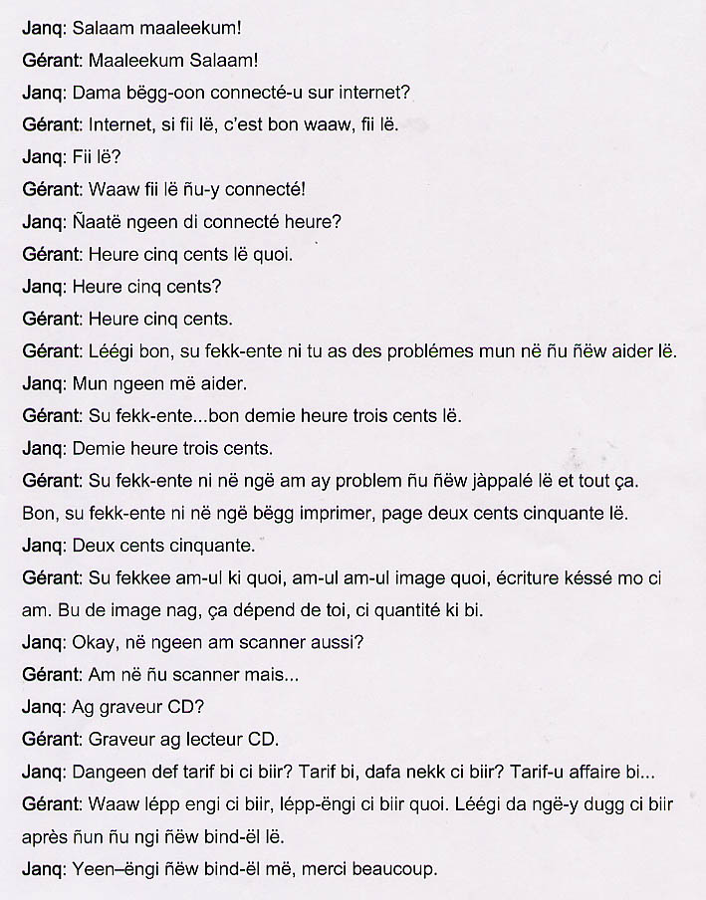

English translation:
"Young Woman: Greetings!
Cyber Man: Greetings!
Young Woman: I'd like to get connected to the internet?
Cyber Man: Internet, it's right here, you are at the right place!
Young Woman: It's here?
Cyber Man: Yes, this is the right place!
Young Woman: How much is it for an hour?
Cyber: It's 500 francs for an hour.
Young Woman: 500 francs per hour?
Cyber Man: 500 francs per hour. Now, if you have any problems we are here to help you.
Young Woman: You can help me.
Cyber Man: If you…well it's 300 francs per half hour.
Young Woman: 300 francs per half hour.
Cyber Man: If you encounter any problems, we will come give you a hand and all.
And if you would like to print, it's 250 francs a page.
Young Woman: 250 francs a page?
Cyber Man: That's if there are no images and the pages only have text. If there are images, it depends on you, on the quantity of the thing.
Young Woman: Okay, do you have a scanner as well?
Cyber Man: We have a scanner but…
Young Woman: And a CD burner?
Cyber Man: CD burner and CD reader.
Young Woman: Do you have the rates inside? The pricing info, is it inside?
Cyber Man: Yes, everything is inside, everything is inside, really. Now you can go inside and we will come write you a time slip.
Young Woman: All right, you'll be coming in to write me a time slip. Thank you very much."

About Language by Country: The Language by Country videos and other materials were produced by the Five College Center for the Study of World Languages between 1999 - 2003 with funding from the National Security Education Program (NSEP) and the Fund for the Improvement of Postsecondary Education (FIPSE) of the U.S. Department of Education. The videos were filmed by Five College international students in their home countries. The goal was to provide examples of authentic language spoken in its natural cultural environment so that students of all ages can better understand the interplay between a language and its culture. We have tried to remain true to the language our subjects actually uttered. Therefore, we have not corrected grammatical errors and the videos sometimes show highly colloquial language, local slang, and regionally specific speech patterns. At times, we have noted the preferred or more standard forms in parentheses. Most of the transcripts and translations were prepared by the same students who filmed the video, although in some cases the transcripts have also been edited by a language expert.
© 2003 Five College Center for the Study of World Languages and Five Colleges, Incorporated

