French and Wolof in Senegal Video Transcripts
Language by Country Collection on LangMedia
http://langmedia.fivecolleges.edu/

"Does Yafaty Diagne Live Here?"

Wolof transcript:
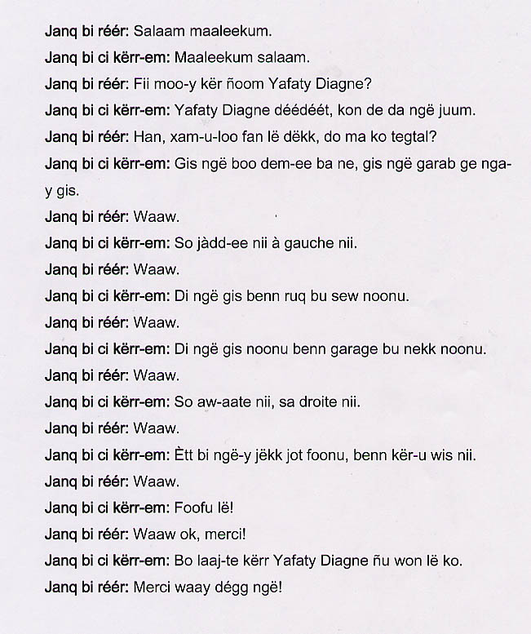

English translation:
"Lost young woman: Greetings!
Young woman: Greetings!
Lost young woman: Does Yafaty Diagne live here?
Young woman: Yafaty Diagne? No, you must have made a mistake.
Lost young woman: Oh really, would you happen to know where she lives, then ? And could you give me directions?
Young woman: Okay, see when you walk up to that tree over there?
Lost young woman: Yes.
Young woman: You make a left.
Lost young woman: Yes.
Young woman: You will come across a very narrow path.
Lost young woman: Yes.
Young woman: You will see a parking garage right there.
Lost young woman: Yes.
Young woman: When you go this way to your right.
Lost young woman: Yes.
Young woman: The first courtyard that you reach with a house made of sandy stones.
Lost young woman: Yes.
Young woman: That's where she lives.
Lost young woman: Yes, all right, thank you.
Young woman: People will take you to her if you ask around.
Lost young woman: All right, thank you !"

About Language by Country: The Language by Country videos and other materials were produced by the Five College Center for the Study of World Languages between 1999 - 2003 with funding from the National Security Education Program (NSEP) and the Fund for the Improvement of Postsecondary Education (FIPSE) of the U.S. Department of Education. The videos were filmed by Five College international students in their home countries. The goal was to provide examples of authentic language spoken in its natural cultural environment so that students of all ages can better understand the interplay between a language and its culture. We have tried to remain true to the language our subjects actually uttered. Therefore, we have not corrected grammatical errors and the videos sometimes show highly colloquial language, local slang, and regionally specific speech patterns. At times, we have noted the preferred or more standard forms in parentheses. Most of the transcripts and translations were prepared by the same students who filmed the video, although in some cases the transcripts have also been edited by a language expert.
© 2003 Five College Center for the Study of World Languages and Five Colleges, Incorporated

