Slovak in Slovakia Video Transcripts
Language by Country Collection on LangMedia
http://langmedia.fivecolleges.edu/

"How Much Tip Should We Give?"

Slovak transcript:
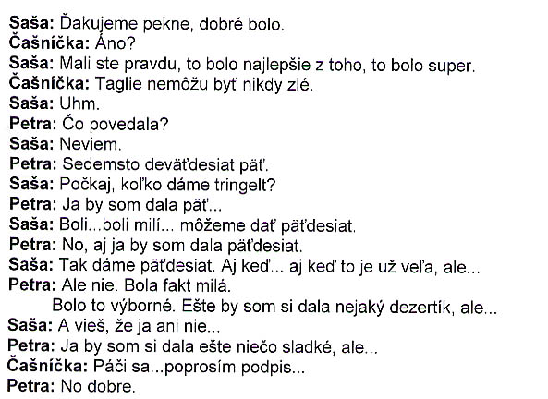

English translation:
"Saša: Thank you very much, it was good.
Waitress: Was it?
Saša: You were right, that was the best; that was awesome.
Waitress: Taglie can never be bad.
Saša: Yeah.
Petra: What did she say?
Saša: I don't know...
Petra: Seven hundred and ninety-five...
Saša: Let's see, how much of a tip are we going to leave?
Petra: I would leave fif...
Saša: They were...they were nice...we can leave fifty.
Petra: Yeah, I would leave fifty, too.
Saša: So let's leave fifty. Even though it's a little too much, but...
Petra: But no. She was really nice.
It was excellent. Now I feel like having a little dessert of some sort, but...
Saša: You know, I don't.
Petra: I feel like having something sweet, but...
Waitress: Here you go. Can you sign that for me, please?
Petra: All right, then."

About Language by Country: The Language by Country videos and other materials were produced by the Five College Center for the Study of World Languages between 1999 - 2003 with funding from the National Security Education Program (NSEP) and the Fund for the Improvement of Postsecondary Education (FIPSE) of the U.S. Department of Education. The videos were filmed by Five College international students in their home countries. The goal was to provide examples of authentic language spoken in its natural cultural environment so that students of all ages can better understand the interplay between a language and its culture. We have tried to remain true to the language our subjects actually uttered. Therefore, we have not corrected grammatical errors and the videos sometimes show highly colloquial language, local slang, and regionally specific speech patterns. At times, we have noted the preferred or more standard forms in parentheses. Most of the transcripts and translations were prepared by the same students who filmed the video, although in some cases the transcripts have also been edited by a language expert.
© 2003 Five College Center for the Study of World Languages and Five Colleges, Incorporated

