Slovak in Slovakia Video Transcripts
Language by Country Collection on LangMedia
http://langmedia.fivecolleges.edu/

"A Dinner at an Italian Restaurant"

Slovak transcript:
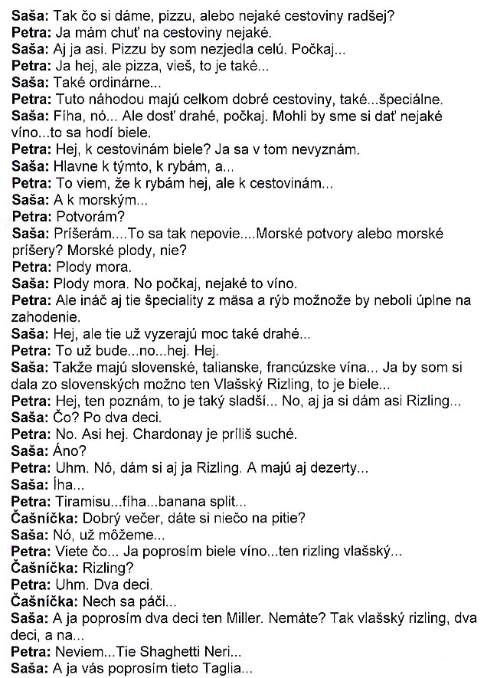
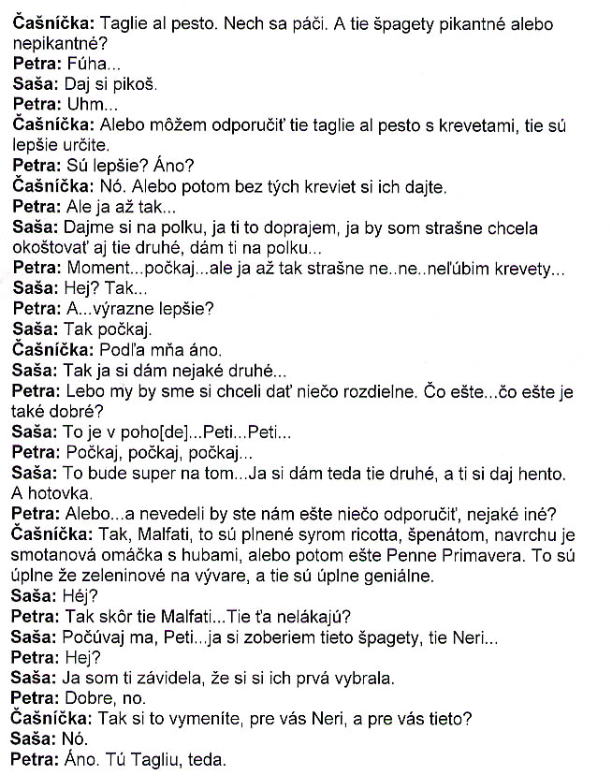

English translation:
"Saša: So what are we having, pizza or some kind of pasta instead?
Petra: I feel like having some kind of pasta.
Saša: Me, too, probably. I couldn't eat a whole pizza.
Petra: I could, but pizza, you know, that's kind of...
Saša: Kind of ordinary...
Petra: Actually, here they have quite good pasta, very...special.
Saša: Wow, yeah. But quite expensive. Wait, we could have some wine...white goes with that.
Petra: White with pasta? I've no idea.
Saša: Mostly with that. With fish, and...
Petra: I know that, that it goes with fish, but with pasta...
Saša: And with sea...
Petra: Creatures?
Saša: Monsters...You don't say that like that...Sea creatures or sea monsters? Sea fruits, no?
Petra: Fruits of the sea.
Saša: Fruits of the sea. All right, so, let's see, some wine.
Petra: Maybe the meat and fish specialties wouldn't be so bad, either.
Saša: Yeah, but those look too expensive.
Petra: That would be...yeah. Yeah.
Saša: Okay, so they have Slovak, Italian, French wine...Maybe I'll pick from the Slovak ones. The Vlassky Rizling, that's white...
Petra: Yeah, I know that one, that's kind of sweetish...Yeah, I'll probably also have a Rizling.
Saša: Yeah? Two deciliters each...
Petra: Yeah. I guess. Chardonnay is too dry.
Saša: Is it?
Petra: Yeah. Yeah, I'l also have a Rizling. And they also have desserts...
Saša: Wow.
Petra: Tiramisu...Wow...Banana split...
Waitress: Good evening, would you like something to drink?
Saša: Yeah, we can [order].
Petra: Let's see...I'll have a white wine...the Rizling Vlassky.
Waitress: Rizling?
Petra: Yeah. Two deciliters.
Waitress: Sure.
Saša: And I, the Miller. You don't have it? Then a Vlassky Rizling, two deciliters, and two...
Petra: I don't know...The Spaghetti Neri...
Saša: And I'll have these Taglia...
Waitress: Taglie al pesto. Sure. And do you want the spaghetti hot or sweet?
Petra: Whoa...
Saša: Have it hot.
Petra: Well...
Waitress: Or I can recommend the Taglie al Pesto with shrimp, those are definitely better.
Petra: They're better? Really?
Waitress: Yeah. Or have them without the shrimp.
Petra: But I don't...
Saša: Let's split it. I want you to have it. I utterly want to try those other ones, too, I'll let you have a half...
Petra: Wait...wait... but I don't like shrimp all that much...
Saša: No? Then...
Petra: And...significantly better?
Saša: Wait...
Waitress: According to me, yes.
Saša: Okay, so I'll have some other kind...
Petra: Because we would like to have something different.
Saša: That's all right...Petra...Petra...
Petra: Wait, wait, wait.
Saša: That's going to be great on the...So I'll have the other one, and you can have that. There.
Petra: Or ... could you maybe recommend us something, something else?
Waitress: Okay. Malfati - those are stuffed with ricotta cheese and spinach and topped with a cream dressing with mushrooms or Penne Primavera. Those are completely, like, vegetables in a sauce and are absolutely awesome.
Saša: Really?
Petra: So, probably the Malfati...You don't like them?
Saša: Listen, Petra...I can have the spaghetti, the Neri.
Petra: Yeah?
Saša: I was envying you that you had chosen them first.
Petra: Okay, then.
Waitress: So you're switching. For you the Neri and for you these?
Saša: Yeah.
Petra: Yes. I'll have the Taglia, then."

About Language by Country: The Language by Country videos and other materials were produced by the Five College Center for the Study of World Languages between 1999 - 2003 with funding from the National Security Education Program (NSEP) and the Fund for the Improvement of Postsecondary Education (FIPSE) of the U.S. Department of Education. The videos were filmed by Five College international students in their home countries. The goal was to provide examples of authentic language spoken in its natural cultural environment so that students of all ages can better understand the interplay between a language and its culture. We have tried to remain true to the language our subjects actually uttered. Therefore, we have not corrected grammatical errors and the videos sometimes show highly colloquial language, local slang, and regionally specific speech patterns. At times, we have noted the preferred or more standard forms in parentheses. Most of the transcripts and translations were prepared by the same students who filmed the video, although in some cases the transcripts have also been edited by a language expert.
© 2003 Five College Center for the Study of World Languages and Five Colleges, Incorporated

