Serbian in Serbia Video Transcripts
Language by Country Collection on LangMedia
http://langmedia.fivecolleges.edu/

"Talking to a Friend from School"

Serbian transcript:
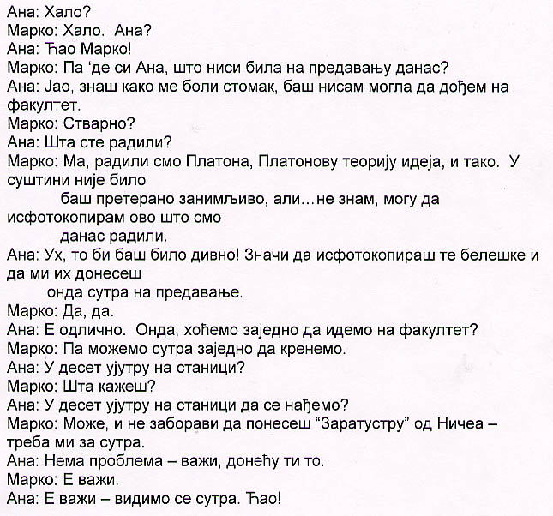

English translation:
"Marko: Hello, Ana (meaning: Ana, is that you)?
Ana: Hey Marko!
Marko: Where have you been? Why didn’t you come to class today?
Ana: Oh, I have a horrible stomachache – I really couldn’t come to class...
Marko: Really?
Ana: What did you do?
Marko: Well, we did Plato, Plato’s theory of ideals and such... It was not overly interesting, but... I
don’t know – I could make you a copy of my notes...
Ana: Wow, that would be wonderful! So, you would photocopy those notes for me and bring them
to class tomorrow...
Marko: Yeah...
Ana: Great... Then, shall we go to class together?
Marko: Yeah, we could leave together...
Ana: At 10 a.m. on the bus stop?
Marko: What did you say?
Ana: Should we meet at 10 a.m. at the bus stop?
Marko: Yes, that would work, and don’t forget to bring “Zarathustra” by Nietzsche – I need it for
tomorrow.
Ana: No problem – I’ll bring it.
Marko: All right...
Ana: Okay – see you tomorrow. Bye!"

About Language by Country: The Language by Country videos and other materials were produced by the Five College Center for the Study of World Languages between 1999 - 2003 with funding from the National Security Education Program (NSEP) and the Fund for the Improvement of Postsecondary Education (FIPSE) of the U.S. Department of Education. The videos were filmed by Five College international students in their home countries. The goal was to provide examples of authentic language spoken in its natural cultural environment so that students of all ages can better understand the interplay between a language and its culture. We have tried to remain true to the language our subjects actually uttered. Therefore, we have not corrected grammatical errors and the videos sometimes show highly colloquial language, local slang, and regionally specific speech patterns. At times, we have noted the preferred or more standard forms in parentheses. Most of the transcripts and translations were prepared by the same students who filmed the video, although in some cases the transcripts have also been edited by a language expert.
© 2003 Five College Center for the Study of World Languages and Five Colleges, Incorporated

