Serbian in Serbia Video Transcripts
Language by Country Collection on LangMedia
http://langmedia.fivecolleges.edu/

"Deciding What to Order"

Serbian transcript:
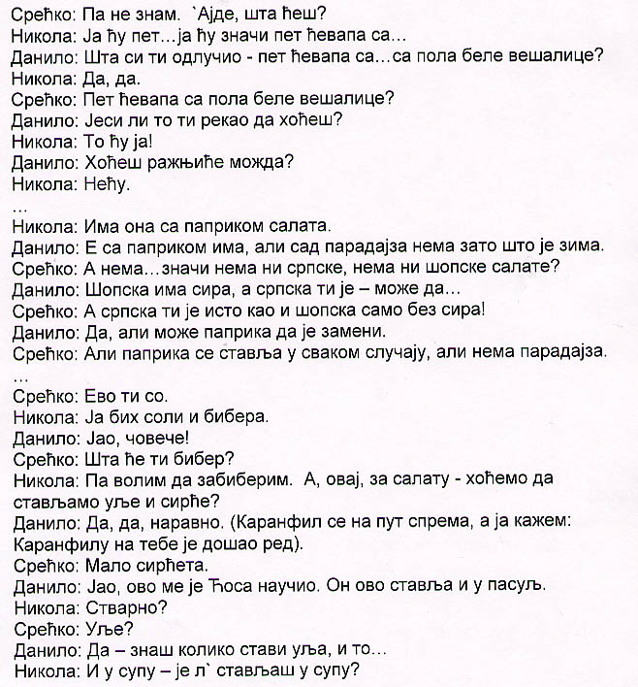
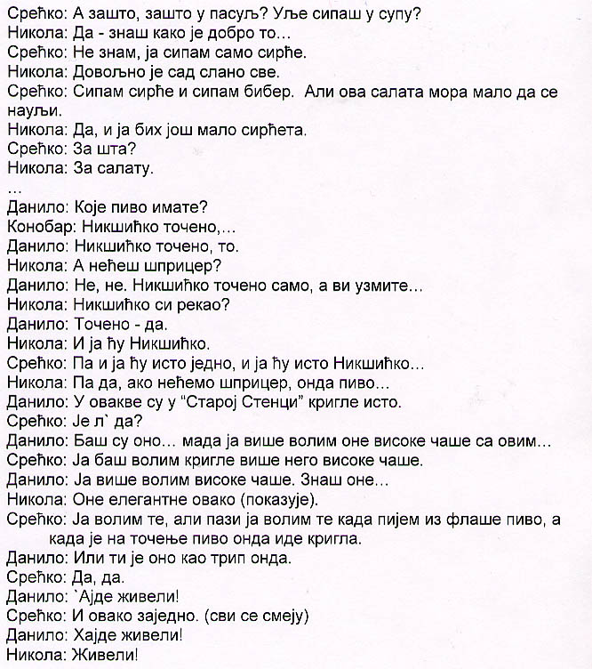

English translation:
"Srecko: I don't know. What are you gonna have?
Nikola: I'm gonna have five … five meat fingers with …
Danilo: What have you decided - five meat fingers and a half of „bela vešalica„?*
Nikola: Yes, yes.
Srecko: Five meat fingers and a half of „bela vešalica„?
Danilo: You said you want that, right?
Nikola: I want that.
Danilo: Would you like meat kebabs, maybe?
Nikola: No.
…
Nikola: They have that salad with peppers.
Danilo: With peppers - yes, but there are no tomatoes now, because it's winter.
Srecko: Oh, no … So, they have neither „Šopska„ nor „Serbian„ salad.
Danilo: „Šopska„ is with cheese, and „Serbian„ …
Srecko: „Serbian„ salad is the same as „Šopska,„ just without cheese!
Danilo: Yes, but peppers can substitute.
Srecko: But you put peppers in it anyway, it just doesn't have tomatoes now.
…
Srecko: Here is your salt.
Nikola: Yeah, I need salt and pepper.
Danilo: Oh, man …
Srecko: Why do you need pepper?
Nikola: Because I like to put pepper on it. Are we also going to put oil and vinegar on our salads?
Danilo: Yes, of course! (makes a joke - talks to his salad … irrelevant to the video)
Srecko: A little bit of vinegar.
Danilo: Cosa taught me this - he even puts it into bean soup.
Nikola: Really?
Srecko: Oil?
Danilo: Yeah, he puts in tons of oil.
Nikola: And the soup - do you put it in a clear broth, too?
Srecko: Why in navy bean soup? You put oil in a clear broth, too?
Nikola: Yes, it really tastes good that way.
Srecko: I only put in vinegar.
Nikola: Now, everything is salty enough.
Srecko: I put in vinegar and pepper, … but this salad needs some oil, too.
Nikola: Yes, and I would like some more vinegar.
Srecko: For what?
Nikola: For the salad.
…
Danilo: What kind of beer do you have?
Waiter: We have „Nikšicko„ on draft, …
Danilo: „Nikšicko„ on draft - that's what I want!
Nikola: You don't want spritzer?
Danilo: No - I want only „Nikšicko„ on draft … you can have whatever you want …
Nikola: You said „Nikšicko„?
Danilo: … on draft - yes!
Nikola: I'll have „Nikšicko„, as well.
Srecko: Then I'll have the same - „Nikšicko„…
Nikola: Yes, if we're not all having spritzers, then beer sounds good …
Danilo: Oh, restaurant „Stara Stenka„ has these same beer mugs.
Nikola: Really?
Danilo: They are really nice, although I prefer those tall glasses.
Srecko: And I like the mugs better than those tall glasses.
Danilo: I like those tall glasses … you know those …
Nikola: Those elegant ones, like this (showing it).
Srecko: Yes, I like those when I have bottled beer, but I think that the mugs go better with draft beer.
Danilo: Oh, so that does it for you?
Srecko: Yeah.
Danilo: All right: cheers!
Srecko: Together, like this …
Danilo: Cheers!
Nikola: Cheers!
*Bela vešalica - very fine pork steak."

About Language by Country: The Language by Country videos and other materials were produced by the Five College Center for the Study of World Languages between 1999 - 2003 with funding from the National Security Education Program (NSEP) and the Fund for the Improvement of Postsecondary Education (FIPSE) of the U.S. Department of Education. The videos were filmed by Five College international students in their home countries. The goal was to provide examples of authentic language spoken in its natural cultural environment so that students of all ages can better understand the interplay between a language and its culture. We have tried to remain true to the language our subjects actually uttered. Therefore, we have not corrected grammatical errors and the videos sometimes show highly colloquial language, local slang, and regionally specific speech patterns. At times, we have noted the preferred or more standard forms in parentheses. Most of the transcripts and translations were prepared by the same students who filmed the video, although in some cases the transcripts have also been edited by a language expert.
© 2003 Five College Center for the Study of World Languages and Five Colleges, Incorporated

