Romanian in Romania Video Transcripts
Language by Country Collection on LangMedia
http://langmedia.fivecolleges.edu/

"Buying Subway Cards"

Romanian transcript:
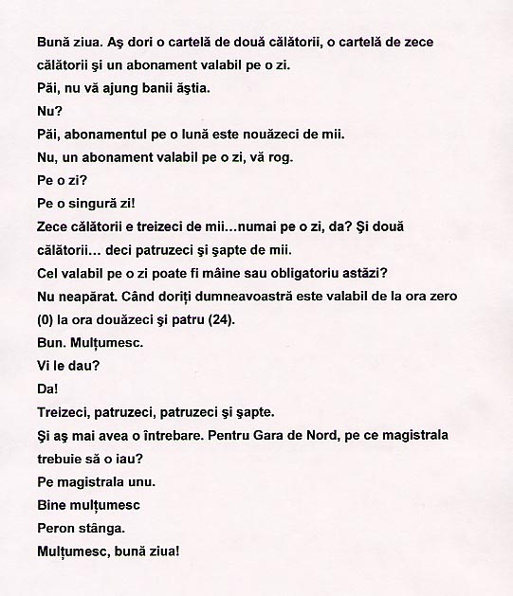

English translation:
"Hello. I would like two-trip card, a ten-trip card and a card valid for one day.
Well, the money is not enough.
No?
Well, the one-month valid card is 90,000.
No, a one-day card, if you please.
For one day?
For one single day.
A ten-trip is 30,000… one day only, right? And a two-trip… so 47,000.
Can I use the one-day card tomorrow, or is it mandatory today?
Not really. You can use it when you need it and it's valid from 0 o'clock to 24 o'clock. (in fact from 0 am it's valid 24 hours)
And I would have one more question. For the North Train Station which thoroughfare should I go?
Take the thoroughfare number one.
Okay thanks.
The platform on your left.
Thank you, goodbye!"

About Language by Country: The Language by Country videos and other materials were produced by the Five College Center for the Study of World Languages between 1999 - 2003 with funding from the National Security Education Program (NSEP) and the Fund for the Improvement of Postsecondary Education (FIPSE) of the U.S. Department of Education. The videos were filmed by Five College international students in their home countries. The goal was to provide examples of authentic language spoken in its natural cultural environment so that students of all ages can better understand the interplay between a language and its culture. We have tried to remain true to the language our subjects actually uttered. Therefore, we have not corrected grammatical errors and the videos sometimes show highly colloquial language, local slang, and regionally specific speech patterns. At times, we have noted the preferred or more standard forms in parentheses. Most of the transcripts and translations were prepared by the same students who filmed the video, although in some cases the transcripts have also been edited by a language expert.
© 2003 Five College Center for the Study of World Languages and Five Colleges, Incorporated

