Romanian in Romania Video Transcripts
Language by Country Collection on LangMedia
http://langmedia.fivecolleges.edu/

"Letters, Postcards, and Telegrams"

Romanian transcript:
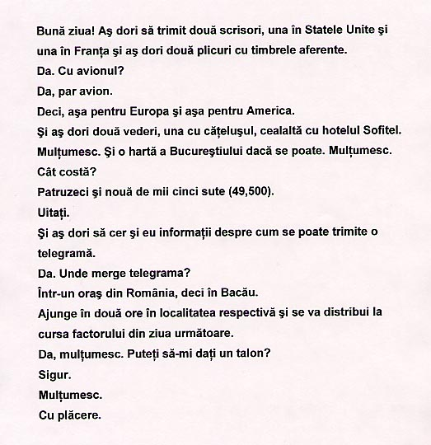

English translation:
"Hi! I want to send two letters, one in the US and one in France, and I would like to buy two envelopes and the stamps needed.
Yes. Airmail?
Yes, airmail.
So, here's for Europe and here's for America.
And I would like two postcards, one with the little doggy, and the other one with the Sofitel Hotel. Thanks. And a map of Bucharest, if possible. Thank you. How much is it?
49,500.
Here.
And I would like to find out information about sending a telegram.
All right. Where does the telegram go?
A city in Romania, well Bacau.
It will get there in two hours, and it will be distributed the next day.
Yes, thanks. Can you give me an application?
Of course.
Thanks.
You are welcome."

About Language by Country: The Language by Country videos and other materials were produced by the Five College Center for the Study of World Languages between 1999 - 2003 with funding from the National Security Education Program (NSEP) and the Fund for the Improvement of Postsecondary Education (FIPSE) of the U.S. Department of Education. The videos were filmed by Five College international students in their home countries. The goal was to provide examples of authentic language spoken in its natural cultural environment so that students of all ages can better understand the interplay between a language and its culture. We have tried to remain true to the language our subjects actually uttered. Therefore, we have not corrected grammatical errors and the videos sometimes show highly colloquial language, local slang, and regionally specific speech patterns. At times, we have noted the preferred or more standard forms in parentheses. Most of the transcripts and translations were prepared by the same students who filmed the video, although in some cases the transcripts have also been edited by a language expert.
© 2003 Five College Center for the Study of World Languages and Five Colleges, Incorporated

