Arabic in Jordan Video Transcripts
Language by Country Collection on LangMedia
http://langmedia.fivecolleges.edu/

"Making Plans with Friends"

Arabic transcript:
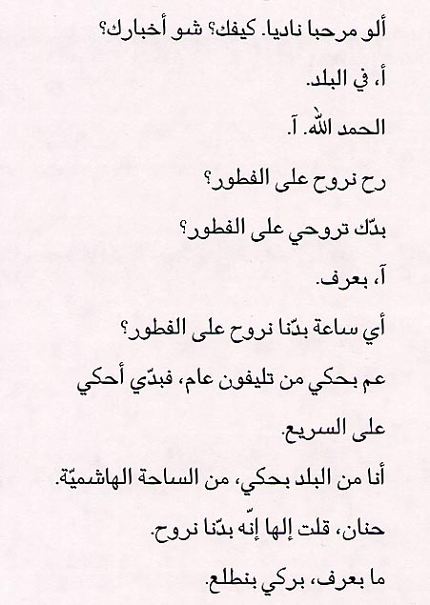
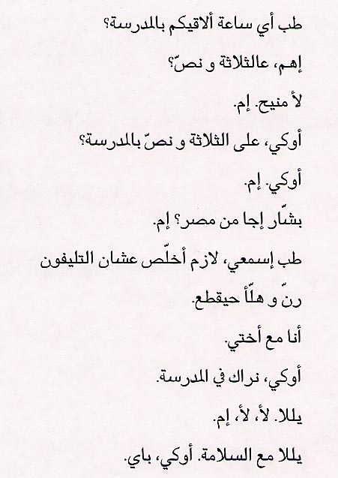

English translation:
"- Alo. Hello Nadia. How are you? What is going on (literally,„what is your news„)?
- Emm (sound meaning „yes„)... Downtown.
- Thanks to God. Yeah.
- Are we going to breakfast (literally, „breaking of the fast meal„)?
- Do you want to go to breakfast?
- Yeah, I know.
- What time are we going to breakfast?
- I am calling from a public telephone, so I want to talk quickly.
- I am calling from downtown, from the Hashimite Plaza.
- I told Hanan that we are going.
- I do not know, maybe we will go out.
- So, what time shall I meet you at school?
- Emm, at half past three?
- No, good. Yes.
- Okay, at half past three at school?
- Okay. Yes.
- Bashaar came from Egypt? Yes.
- Okay, listen, I need to finish because the phone rang and is going to disconnect now.
- I am with my sister.
- Okay, see you at school.
- All right. No. No. Yes.
- All right, goodbye (literally, „with safety„). Okay, bye."

About Language by Country: The Language by Country videos and other materials were produced by the Five College Center for the Study of World Languages between 1999 - 2003 with funding from the National Security Education Program (NSEP) and the Fund for the Improvement of Postsecondary Education (FIPSE) of the U.S. Department of Education. The videos were filmed by Five College international students in their home countries. The goal was to provide examples of authentic language spoken in its natural cultural environment so that students of all ages can better understand the interplay between a language and its culture. We have tried to remain true to the language our subjects actually uttered. Therefore, we have not corrected grammatical errors and the videos sometimes show highly colloquial language, local slang, and regionally specific speech patterns. At times, we have noted the preferred or more standard forms in parentheses. Most of the transcripts and translations were prepared by the same students who filmed the video, although in some cases the transcripts have also been edited by a language expert.
© 2003 Five College Center for the Study of World Languages and Five Colleges, Incorporated

