Japanese in Japan Video Transcripts
Language by Country Collection on LangMedia
http://langmedia.fivecolleges.edu/

"Buying Stamps"

Japanese transcript:
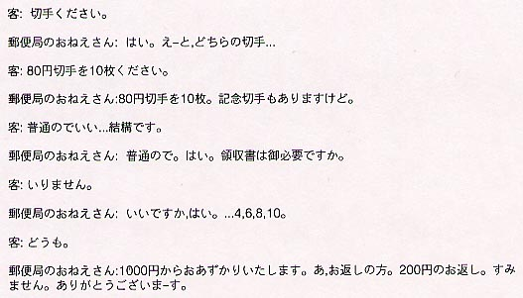

English translation:
"Customer: Can I please have some stamps?
Clerk: Sure. Which stamps?
Customer: Can I please have ten 80-yen stamps?
Clerk: Ten 80-yen stamps. We also have special anniversary stamps.
Customer: The regular kind would be fine.
Clerk: Regular kind. (In Japan it is polite for the clerk to repeat the customer's request as a way of confirming it.) Okay, would you like a receipt?
Customer: That wouldn't be necessary.
Clerk: Don't need one, okay. …4,6,8,10.
Customer: Thank you.
Clerk: From 1000 yen. Oh, your change. 200 yen is your change. Sorry. Thank you very much."

About Language by Country: The Language by Country videos and other materials were produced by the Five College Center for the Study of World Languages between 1999 - 2003 with funding from the National Security Education Program (NSEP) and the Fund for the Improvement of Postsecondary Education (FIPSE) of the U.S. Department of Education. The videos were filmed by Five College international students in their home countries. The goal was to provide examples of authentic language spoken in its natural cultural environment so that students of all ages can better understand the interplay between a language and its culture. We have tried to remain true to the language our subjects actually uttered. Therefore, we have not corrected grammatical errors and the videos sometimes show highly colloquial language, local slang, and regionally specific speech patterns. At times, we have noted the preferred or more standard forms in parentheses. Most of the transcripts and translations were prepared by the same students who filmed the video, although in some cases the transcripts have also been edited by a language expert.
© 2003 Five College Center for the Study of World Languages and Five Colleges, Incorporated

