Greek in Greece Video Transcripts
Language by Country Collection on LangMedia
http://langmedia.fivecolleges.edu/

"A Weather Forecast"

Greek transcript:
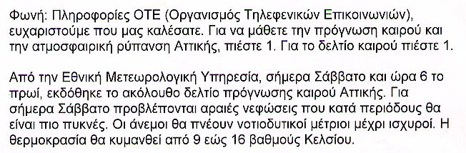

English translation:
"Voice: Information OTE, thank you for calling. To learn the weather forecast and the pollution status in Attika, press one. For the weather report, press one.
From the National Weather Forecasting Service, today, Saturday, at 6:00 a.m., the following weather was reported. For today, Saturday, we forecast clouds that at some point might increase. The wind will be blowing toward the southwest at moderate speed. The temperature will be between nine and sixteen degrees Celsius."

About Language by Country: The Language by Country videos and other materials were produced by the Five College Center for the Study of World Languages between 1999 - 2003 with funding from the National Security Education Program (NSEP) and the Fund for the Improvement of Postsecondary Education (FIPSE) of the U.S. Department of Education. The videos were filmed by Five College international students in their home countries. The goal was to provide examples of authentic language spoken in its natural cultural environment so that students of all ages can better understand the interplay between a language and its culture. We have tried to remain true to the language our subjects actually uttered. Therefore, we have not corrected grammatical errors and the videos sometimes show highly colloquial language, local slang, and regionally specific speech patterns. At times, we have noted the preferred or more standard forms in parentheses. Most of the transcripts and translations were prepared by the same students who filmed the video, although in some cases the transcripts have also been edited by a language expert.
© 2003 Five College Center for the Study of World Languages and Five Colleges, Incorporated

