Greek in Greece Video Transcripts
Language by Country Collection on LangMedia
http://langmedia.fivecolleges.edu/

"Buying Cold Remedies"

Greek transcript:
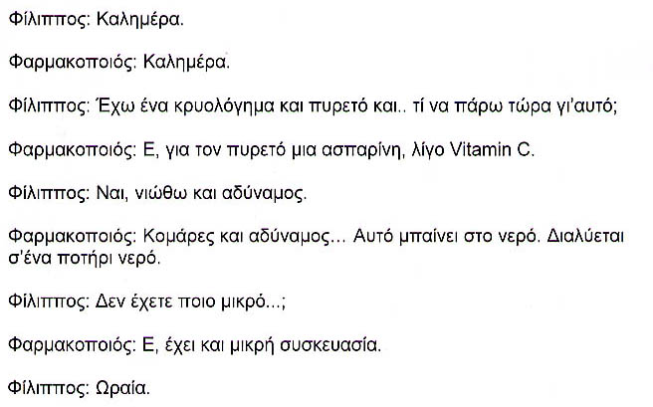
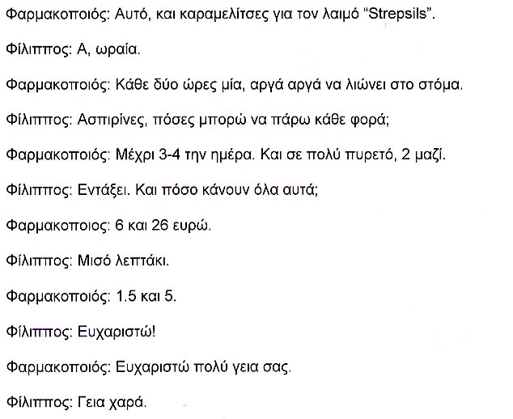

English translation:
"Filippos: Good Morning.
Pharmacist: Good Morning.
Filippos: I have a cold and a fever and … what should I take for that?
Pharmacist: Um, for the fever, aspirin and some vitamin C.
Filippos: Yes, I feel weak, too.
Pharmacist: Fever and weakness...This goes into the water. It dissolves in a glass of water.
Filippos: Don't you have a smaller …
Pharmacist: Uh, there is a smaller container.
Filippos: Good.
Pharmacist: This, and cough drops, „Strepsils.„
Filippos: Oh, good.
Pharmacist: One every two hours. Slowly, let it melt in your mouth.
Filippos: Aspirin, how many can I take at a time?
Pharmacist: Up to three or four a day. And for a high fever, two at a time.
Filippos: Okay. And how much does all of this cost?
Pharmacist: 6 euros and 26.
Filippos: One second.
Pharmacist: 1.5 and 5.
Filippos: Thank you!
Pharmacist: Thank you very much."

About Language by Country: The Language by Country videos and other materials were produced by the Five College Center for the Study of World Languages between 1999 - 2003 with funding from the National Security Education Program (NSEP) and the Fund for the Improvement of Postsecondary Education (FIPSE) of the U.S. Department of Education. The videos were filmed by Five College international students in their home countries. The goal was to provide examples of authentic language spoken in its natural cultural environment so that students of all ages can better understand the interplay between a language and its culture. We have tried to remain true to the language our subjects actually uttered. Therefore, we have not corrected grammatical errors and the videos sometimes show highly colloquial language, local slang, and regionally specific speech patterns. At times, we have noted the preferred or more standard forms in parentheses. Most of the transcripts and translations were prepared by the same students who filmed the video, although in some cases the transcripts have also been edited by a language expert.
© 2003 Five College Center for the Study of World Languages and Five Colleges, Incorporated

