Twi in Ghana Video Transcripts
Language by Country Collection on LangMedia
http://langmedia.fivecolleges.edu/

"Getting on a Tro-tro"

Twi transcript:
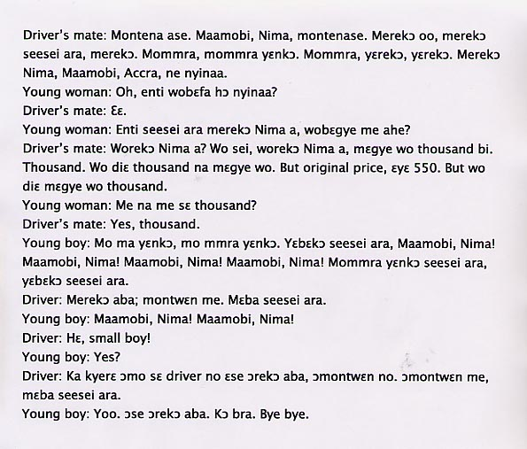

English translation:
"Driver’s mate: Come sit down. Maamobi, Nima, come sit down. I’m leaving, I’m leaving very soon, I’m leaving. Come, Come, let’s go. Come, we’re leaving, we’re leaving. I’m going to Nima, Maamobi, Accra, all those places.
Young woman: Oh, so you’re going to all those places?
Driver’s mate: Yes.
Young woman: So if I were going to Nima right now, how much would you charge me?
Driver’s mate: If you were going to Nima? You, for example, if you were going to Nima, I would charge you one thousand cedis. One thousand… I would charge you one thousand cedis. But the original price is actually 550. But for you, I would charge one thousand.
Young woman: Do I look like someone who can pay one thousand?
Driver’s mate: Yes, a thousand.
Young boy: Let’s go, come on, let’s go. We are leaving very soon, Maamobi, Nima! Maamobi, Nima! Maamobi, Nima! Maamobi, Nima! Come, let’s leave soon, we are leaving very soon.
Driver: I’ll be back, wait for me. I’ll be back very soon.
Young boy: Maamobi, Nima! Maamobi, Nima!
Driver: Hey, little boy!
Young boy: Yes?
Driver: Tell them the driver said he would be back, they should wait for him. Let them wait for me, I’ll be back very soon.
Young boy: Okay. He says he’ll be back. Come back safely. Bye bye."

About Language by Country: The Language by Country videos and other materials were produced by the Five College Center for the Study of World Languages between 1999 - 2003 with funding from the National Security Education Program (NSEP) and the Fund for the Improvement of Postsecondary Education (FIPSE) of the U.S. Department of Education. The videos were filmed by Five College international students in their home countries. The goal was to provide examples of authentic language spoken in its natural cultural environment so that students of all ages can better understand the interplay between a language and its culture. We have tried to remain true to the language our subjects actually uttered. Therefore, we have not corrected grammatical errors and the videos sometimes show highly colloquial language, local slang, and regionally specific speech patterns. At times, we have noted the preferred or more standard forms in parentheses. Most of the transcripts and translations were prepared by the same students who filmed the video, although in some cases the transcripts have also been edited by a language expert.
© 2003 Five College Center for the Study of World Languages and Five Colleges, Incorporated

