Twi in Ghana Video Transcripts
Language by Country Collection on LangMedia
http://langmedia.fivecolleges.edu/

"Buying Medicine with a Prescription"

Twi transcript:
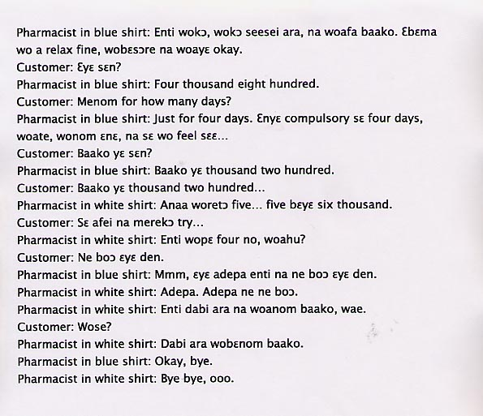

English translation:
"Pharmacist in blue shirt: So when you get home today, take one of these.
It’ll relax you; by the time you wake up, you’ll be okay.
Customer: How much is it?
Pharmacist in blue shirt: Four thousand eight hundred.
Customer: How many days do I take it for?
Pharmacist in blue shirt: Just for four days. You don’t have
to take it for four days, you hear, if you take it today and you feel…
Customer: How much is it for only one?
Pharmacist in blue shirt: One is 1,200.
Customer: One is 1,200…
Pharmacist in white shirt: Or you can buy five… that comes to six thousand.
Customer: Well, for now I’m just going to try it…
Pharmacist in white shirt: So you only want four, right?
Customer: It’s so expensive.
Pharmacist in blue shirt: Yes, it’s a quality brand. That’s why it’s expensive.
Pharmacist in white shirt: Quality brands. Quality brands are priced differently. So take one per day, okay?
Customer: Pardon?
Pharmacist in white shirt: You need to take one per day.
Pharmacist in blue shirt: Okay, bye.
Pharmacist in white shirt: Bye bye, oh."

About Language by Country: The Language by Country videos and other materials were produced by the Five College Center for the Study of World Languages between 1999 - 2003 with funding from the National Security Education Program (NSEP) and the Fund for the Improvement of Postsecondary Education (FIPSE) of the U.S. Department of Education. The videos were filmed by Five College international students in their home countries. The goal was to provide examples of authentic language spoken in its natural cultural environment so that students of all ages can better understand the interplay between a language and its culture. We have tried to remain true to the language our subjects actually uttered. Therefore, we have not corrected grammatical errors and the videos sometimes show highly colloquial language, local slang, and regionally specific speech patterns. At times, we have noted the preferred or more standard forms in parentheses. Most of the transcripts and translations were prepared by the same students who filmed the video, although in some cases the transcripts have also been edited by a language expert.
© 2003 Five College Center for the Study of World Languages and Five Colleges, Incorporated

