Twi in Ghana Video Transcripts
Language by Country Collection on LangMedia
http://langmedia.fivecolleges.edu/

"Buying Palm Oil"

Twi transcript:
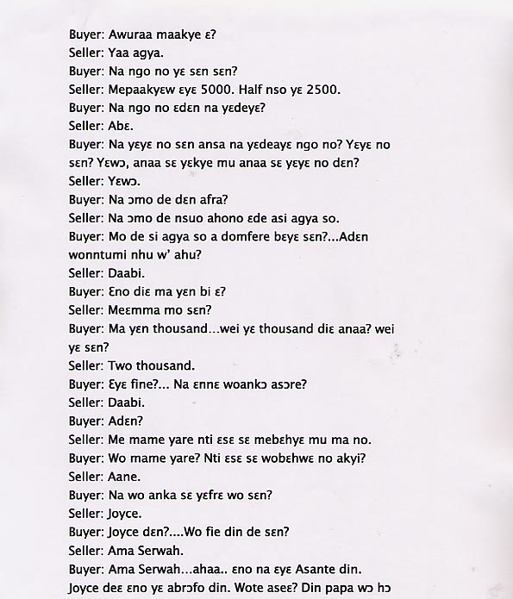
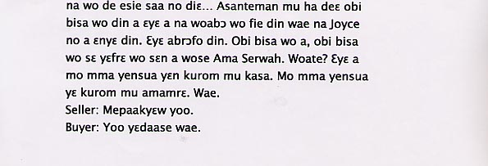

English translation:
"Buyer: Good Morning Miss.
Seller: Yes Father.
Buyer: How much is the palm oil?
Seller: Please it is 5000. Half a bottle is also 2500.
Buyer: And what do they make palm oil with?
Seller: Palm.
Buyer: What process do they go through before the palm oil is ready. How do they make it? Does it have to be pounded or fried or what do we do with it?
Seller: It is pounded.
Buyer: And we mix it up with what?
Seller: Then you mix it up with water so that the palm juices dissolve then you put it on a fire to boil.
Buyer: You put it on a fire for how long? Or you don’t know?
Seller: No
Buyer: All right then give us some.
Seller: How much should I give you?
Buyer: Give us a thousand. Is this the thousand cedi one?
Seller: Two thousand.
Buyer: Is it good quality? And today didn’t you go to church?
Seller: No.
Buyer: Why?
Seller: My mother is sick so I had to come and fill in for her.
Buyer: Your mom is sick? So you have to come and replace her?
Seller: Yes.
Buyer: And you what is your name?
Seller: Joyce.
Buyer: Joyce what?....And what is your traditional name?
Seller: Ama Serwah.
Buyer: Ama Serwah…ahaa… that is an Ashanti name. As for Joyce that is a European name. Do you understand? You have a good name like that. In Asanti land when someone asks for your name you should give your traditional name. As for Joyce, it is not a name. It is a white name. When anyone asks you, your name is Ama Serwah. Okay? We should learn our language and our customs. Okay?
Seller: Yes please.
Buyer: Okay. Thank you."

About Language by Country: The Language by Country videos and other materials were produced by the Five College Center for the Study of World Languages between 1999 - 2003 with funding from the National Security Education Program (NSEP) and the Fund for the Improvement of Postsecondary Education (FIPSE) of the U.S. Department of Education. The videos were filmed by Five College international students in their home countries. The goal was to provide examples of authentic language spoken in its natural cultural environment so that students of all ages can better understand the interplay between a language and its culture. We have tried to remain true to the language our subjects actually uttered. Therefore, we have not corrected grammatical errors and the videos sometimes show highly colloquial language, local slang, and regionally specific speech patterns. At times, we have noted the preferred or more standard forms in parentheses. Most of the transcripts and translations were prepared by the same students who filmed the video, although in some cases the transcripts have also been edited by a language expert.
© 2003 Five College Center for the Study of World Languages and Five Colleges, Incorporated

