Twi in Ghana Video Transcripts
Language by Country Collection on LangMedia
http://langmedia.fivecolleges.edu/

"Buying Milo in a Store"

Twi transcript:
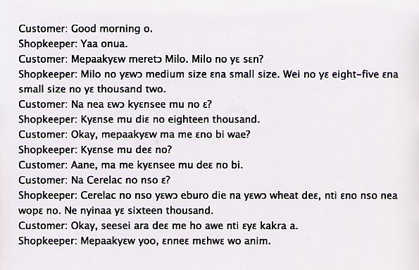

English translation:
"Customer: Good morning.
Shopkeeper: Good morning to you too (lit: I hear/respond to you.).
Customer: Please, I want to buy some Milo. How much is Milo?
Shopkeeper: For Milo, we have a medium-size and a small one. This one is eight thousand five hundred cedis and the small one is one thousand two hundred cedis.
Customer: How about the one in the tin?
Shopkeeper: The one in the tin is eighteen thousand cedis.
Customer: Okay, please give me that one.
Shopkeeper: The one on the tin?
Customer: Yes, give me the one in the tin. What about the Cerelac? (Cerelac is a cereal powder for babies.)
Shopkeeper: For the Cerelac, we have one made from maize and one from wheat. I’ll give you whichever you prefer. Both cost sixteen thousand.
Customer: Okay, right now, I have no more money so I’ll come later.
Shopkeeper: In that case, I’ll look forward to seeing you again."

About Language by Country: The Language by Country videos and other materials were produced by the Five College Center for the Study of World Languages between 1999 - 2003 with funding from the National Security Education Program (NSEP) and the Fund for the Improvement of Postsecondary Education (FIPSE) of the U.S. Department of Education. The videos were filmed by Five College international students in their home countries. The goal was to provide examples of authentic language spoken in its natural cultural environment so that students of all ages can better understand the interplay between a language and its culture. We have tried to remain true to the language our subjects actually uttered. Therefore, we have not corrected grammatical errors and the videos sometimes show highly colloquial language, local slang, and regionally specific speech patterns. At times, we have noted the preferred or more standard forms in parentheses. Most of the transcripts and translations were prepared by the same students who filmed the video, although in some cases the transcripts have also been edited by a language expert.
© 2003 Five College Center for the Study of World Languages and Five Colleges, Incorporated

