Twi in Ghana Video Transcripts
Language by Country Collection on LangMedia
http://langmedia.fivecolleges.edu/

"A Plantains Vendor"

Twi transcript:
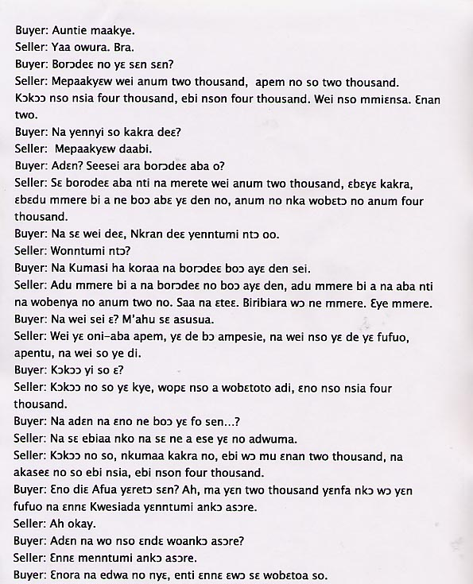
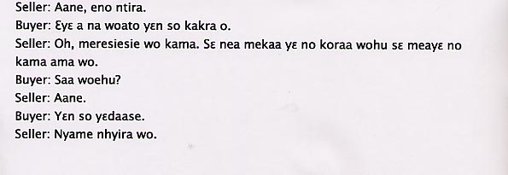

English translation:
"Buyer: Good morning Auntie.
Seller: Yes Mister. Come.
Buyer: How much is the plaintain? [1]
Seller: Please five are two thousand; 'apem' is also two thousand. [2] Some are gathered in twos and threes, those are also two. The ripe plantain is also six for four thousand; some are seven in a bunch.
Buyer: And won’t you reduce it a little?
Seller: No, please.
Buyer: Why not? Right now plantains are in season you know.
Seller: It is because plantains are in season that is why you are getting them in bunches of five at two thousand. In a little while, at a time when it is expensive, you will have to buy five for four thousand.
Buyer: Then in Accra it is going to be so ridiculously expensive that we cannot afford it.
Seller: You won’t be able to afford it?
Buyer: Well even in Kumasi plantains are this expensive
Seller: Well, it gets to a time when plantains are expensive and there are times when it is in season and because they are in season you can get them for five for two. You see everything has its season. It is about seasons.
Seller: This is ‘Oni aba apem.’ [3] We use it for 'ampesie.' [4] And this one we use for fufu [5] and we eat this one.
Buyer: And these ripe plantains?
Seller: Well we fry ripe plantains and if you want you can roast it and eat. That one is sold six for four thousand.
Buyer: And how come that is cheaper than…?
Seller:. Of course because each has its different function.
Seller: And the ripe plantains, the smaller bunches, are going for four for two thousand and the larger bunches are going for six, seven for four thousand.
Buyer: Okay, Afua how much should we buy? Okay, give us some two thousand to go and make some fufu. You know today we couldn’t go to church. And how come you didn’t go to church?
Seller: Well today I couldn’t go to church.
Buyer: Yesterday you didn’t sell too much so you came today to continue.
Seller: Yeah that is the reason.
Buyer: Don’t forget to give us some extra.
Seller: Oh I have really given you a good package. I mean, as I said, I have given some special treatment.
Buyer: Really? Well we are thankful.
Seller: God bless you.
[1] There are two categories of plantain, ripe and unripe. The speaker refers to the unripe variety.
[2] There are also two different types of unripe plantain. 'Apem' are the smaller sized plantains. These are just boiled for meals. Then there are the larger plaintains which are boiled and pounded into the Ghanaian dish called fufu.
[3] Literally means ‘eyes have come’ apem.
[4] A Ghanaian dish made of an eggplant or spinach sauce with yams and plantains.
[5] Another Ghanaian dish made of pounded plantain with palm nut, peanut or tomato soup."

About Language by Country: The Language by Country videos and other materials were produced by the Five College Center for the Study of World Languages between 1999 - 2003 with funding from the National Security Education Program (NSEP) and the Fund for the Improvement of Postsecondary Education (FIPSE) of the U.S. Department of Education. The videos were filmed by Five College international students in their home countries. The goal was to provide examples of authentic language spoken in its natural cultural environment so that students of all ages can better understand the interplay between a language and its culture. We have tried to remain true to the language our subjects actually uttered. Therefore, we have not corrected grammatical errors and the videos sometimes show highly colloquial language, local slang, and regionally specific speech patterns. At times, we have noted the preferred or more standard forms in parentheses. Most of the transcripts and translations were prepared by the same students who filmed the video, although in some cases the transcripts have also been edited by a language expert.
© 2003 Five College Center for the Study of World Languages and Five Colleges, Incorporated

