Twi in Ghana Video Transcripts
Language by Country Collection on LangMedia
http://langmedia.fivecolleges.edu/

"Buying Vegetables"

Twi transcript:
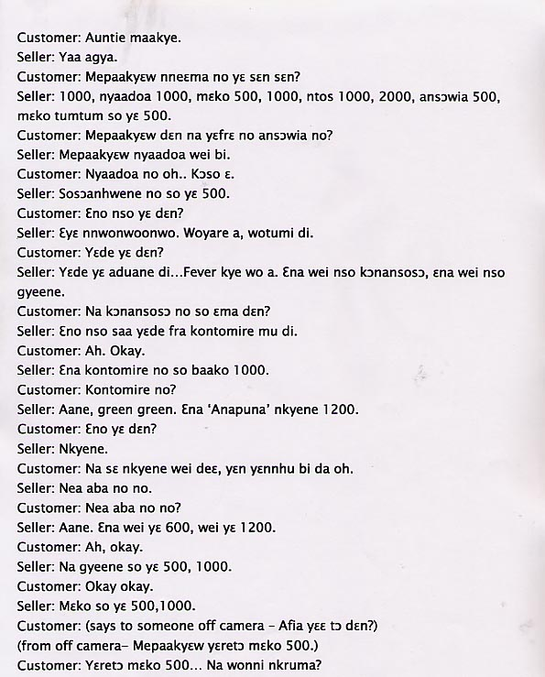


English translation:
"Customer: Auntie, good morning.
Seller: Yes, Father.
Customer: Please, how much do your items cost?
Seller: 1000, eggplant 1000, peppers 500, 1000, tomatoes 1000, 2000, eggplant (a pale yellow variety, literally named: 'did not touch the sun') 500, dark colored peppers, 500.
Customer: Please, what is â€˜ansÉ”wiaâ€™?
Seller: Please, that is this type of eggplant.
Customer: Eggplantâ€¦ I see.
Seller: 'SosÉ”anhwene' is also 500.
Customer: And whatâ€™s that?
Seller: Itâ€™s very bitter. When youâ€™re sick you can take it.
Customer: What is it used for?
Seller: Itâ€™s used to prepare food when you have a fever. This is 'kÉ”nansosÉ”' (another herb), and these are onions.
Customer: And â€˜kÉ”nansosÉ”â€™ is also what?
Seller: It is the same (or it has the same purpose as 'sosÉ”anhwene'). Itâ€™s mixed with kontomire (leaves of the cocyman plant, similar to spinach) and eaten.
Customer: Ah, okay.
Seller: And, the kontomire is also 1000 for one bundle.
Customer: The kontomire?
Seller: Yes, â€˜green greenâ€™. And â€˜Anapunaâ€™ salt is 1200.
Customer: Whatâ€™s that?
Seller: Salt.
Customer: But this salt, weâ€™ve never heard of it before.
Seller: Thatâ€™s whatâ€™s popular.
Customer: Thatâ€™s whatâ€™s popular?
Seller: Yes. This is 600, this is 1200.
Customer: Ah, okay.
Seller: And onions are 500, 1000.
Customer: Okay, okay.
Seller: Pepper is 500, 1000.
Customer: (to someone off camera) Afia, what are we buying?
From off camera: Please, weâ€™re buying 500 worth of pepper.
Customer: We are buying 500 worth of pepperâ€¦ But donâ€™t you have okra?
Seller: We have okra. Okra is 500, 1000.
Customer: Ah, okay. Please give us 500 worth of okra. Whatâ€™s our total?
Seller: 1000."

About Language by Country: The Language by Country videos and other materials were produced by the Five College Center for the Study of World Languages between 1999 - 2003 with funding from the National Security Education Program (NSEP) and the Fund for the Improvement of Postsecondary Education (FIPSE) of the U.S. Department of Education. The videos were filmed by Five College international students in their home countries. The goal was to provide examples of authentic language spoken in its natural cultural environment so that students of all ages can better understand the interplay between a language and its culture. We have tried to remain true to the language our subjects actually uttered. Therefore, we have not corrected grammatical errors and the videos sometimes show highly colloquial language, local slang, and regionally specific speech patterns. At times, we have noted the preferred or more standard forms in parentheses. Most of the transcripts and translations were prepared by the same students who filmed the video, although in some cases the transcripts have also been edited by a language expert.
© 2003 Five College Center for the Study of World Languages and Five Colleges, Incorporated

