Twi in Ghana Video Transcripts
Language by Country Collection on LangMedia
http://langmedia.fivecolleges.edu/

"Buying Egg Fried Rice"

Twi transcript:
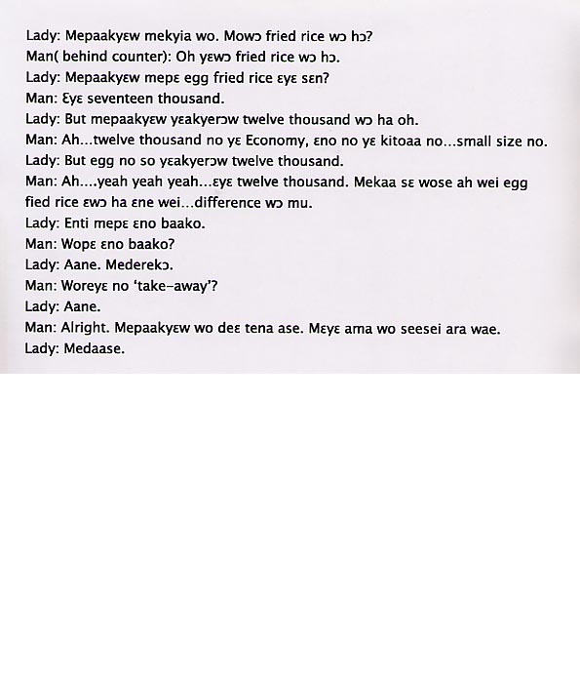

English translation:
"Lady: Greetings. Do you have fried rice?
Man (behind counter): Oh, we have fried rice.
Lady: If you please, how much does the egg fried rice cost?
Man: It’s seventeen thousand.
Lady: But, excuse me, they have twelve thousand written here.
Man: Ah…twelve thousand is for the economy (sized meal), that’s the small size.
Lady: But the egg (fried rice) also has twelve thousand written on it.
Man: Ah….yeah, yeah, yeah…it’s twelve thousand. I thought you wanted egg fried rice on one side and something else on another… there’s a difference.
Lady: So how much is one portion?
Man: You want one?
Lady: Yes. I’m taking it with me.
Man: You want it to go?
Lady: Yes.
Man: All right. Please sit down. I’ll have your order for you in no time.
Lady: Thank you."

About Language by Country: The Language by Country videos and other materials were produced by the Five College Center for the Study of World Languages between 1999 - 2003 with funding from the National Security Education Program (NSEP) and the Fund for the Improvement of Postsecondary Education (FIPSE) of the U.S. Department of Education. The videos were filmed by Five College international students in their home countries. The goal was to provide examples of authentic language spoken in its natural cultural environment so that students of all ages can better understand the interplay between a language and its culture. We have tried to remain true to the language our subjects actually uttered. Therefore, we have not corrected grammatical errors and the videos sometimes show highly colloquial language, local slang, and regionally specific speech patterns. At times, we have noted the preferred or more standard forms in parentheses. Most of the transcripts and translations were prepared by the same students who filmed the video, although in some cases the transcripts have also been edited by a language expert.
© 2003 Five College Center for the Study of World Languages and Five Colleges, Incorporated

