Twi in Ghana Video Transcripts
Language by Country Collection on LangMedia
http://langmedia.fivecolleges.edu/

"Where is the Kaneishe-North School?"

Twi transcript:
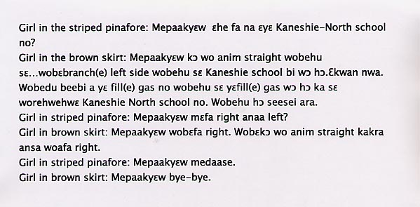

English translation:
"Girl in the striped pinafore: Please, where is the Kaneshie-North school?
Girl in the brown skirt: Please, go straight ahead and you’ll see… you’ll take a left turn and you’ll see there is a Kaneshie school there. It’s not very far away. You’ll get to the gas station, you’ll see them pumping gas. Just say that you’re looking for Kaneshie-North school. You’ll see the place right away.
Girl in striped pinafore: Please, should I take a right or left?
Girl in brown skirt: Please, you turn right. Then go straight ahead for a little while before you take the right.
Girl in striped pinafore: Please, thank you very much.
Girl in brown skirt: Please, bye."

About Language by Country: The Language by Country videos and other materials were produced by the Five College Center for the Study of World Languages between 1999 - 2003 with funding from the National Security Education Program (NSEP) and the Fund for the Improvement of Postsecondary Education (FIPSE) of the U.S. Department of Education. The videos were filmed by Five College international students in their home countries. The goal was to provide examples of authentic language spoken in its natural cultural environment so that students of all ages can better understand the interplay between a language and its culture. We have tried to remain true to the language our subjects actually uttered. Therefore, we have not corrected grammatical errors and the videos sometimes show highly colloquial language, local slang, and regionally specific speech patterns. At times, we have noted the preferred or more standard forms in parentheses. Most of the transcripts and translations were prepared by the same students who filmed the video, although in some cases the transcripts have also been edited by a language expert.
© 2003 Five College Center for the Study of World Languages and Five Colleges, Incorporated

