Twi in Ghana Video Transcripts
Language by Country Collection on LangMedia
http://langmedia.fivecolleges.edu/

"Roasting Chickens"

Twi transcript:
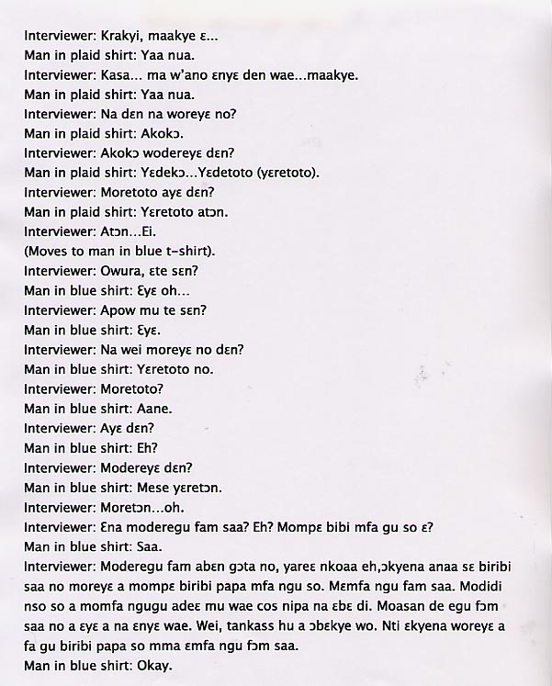

English translation:
"Interviewer: Good morning, gentleman.
Man in plaid shirt: Good morning (response is specific to the age group of person being addressed. In this case the people are relatively close in age).
Interviewer: Speak loudly. Good morning.
Man in plaid shirt: Good morning.
Interviewer: So, what are you doing?
Man in plaid shirt: Chicken.
Interviewer: Chicken…what are you doing with it?
Man in plaid shirt: We’re going to…we’re roasting it.
Interviewer: What are you roasting it for?
Man in plaid shirt: We are roasting it to sell it.
Interviewer: To sell…eh?
(Moves to man in blue t-shirt)
Interviewer: Young man, how are you?
Man in blue shirt: Fine…
Interviewer: How’s life?
Man in blue shirt: Fine.
Interviewer: And this, what are you doing to it?
Man in blue shirt: We’re roasting it.
Interviewer: Roasting?
Man in blue shirt: Yes.
Interviewer: What for?
Man in blue shirt: Eh?
Interviewer: What are you using them for?
Man in blue shirt: I said we were selling them.
Interviewer: Selling them…oh. So why is it on the floor like this? Eh? Why don’t you find something to put it on?
Man in blue shirt: Really?
Interviewer: You have put it too close to the gutter; a prime breeding place for diseases. The next time you’re doing this, find something to put it on. Don’t put it on the floor like that. As well, when you’re eating, find something to put it on, because human beings will be eating this food. When you put it on the floor like that, it is not sanitary. You know that if the authorities see this you’ll be arrested. So next time you are doing this, put the stuff on something good; don’t put it on the floor like that.
Man in blue shirt: Okay."

About Language by Country: The Language by Country videos and other materials were produced by the Five College Center for the Study of World Languages between 1999 - 2003 with funding from the National Security Education Program (NSEP) and the Fund for the Improvement of Postsecondary Education (FIPSE) of the U.S. Department of Education. The videos were filmed by Five College international students in their home countries. The goal was to provide examples of authentic language spoken in its natural cultural environment so that students of all ages can better understand the interplay between a language and its culture. We have tried to remain true to the language our subjects actually uttered. Therefore, we have not corrected grammatical errors and the videos sometimes show highly colloquial language, local slang, and regionally specific speech patterns. At times, we have noted the preferred or more standard forms in parentheses. Most of the transcripts and translations were prepared by the same students who filmed the video, although in some cases the transcripts have also been edited by a language expert.
© 2003 Five College Center for the Study of World Languages and Five Colleges, Incorporated

