Twi in Ghana Video Transcripts
Language by Country Collection on LangMedia
http://langmedia.fivecolleges.edu/

"What is the Kawuro Made of?"

Twi transcript:
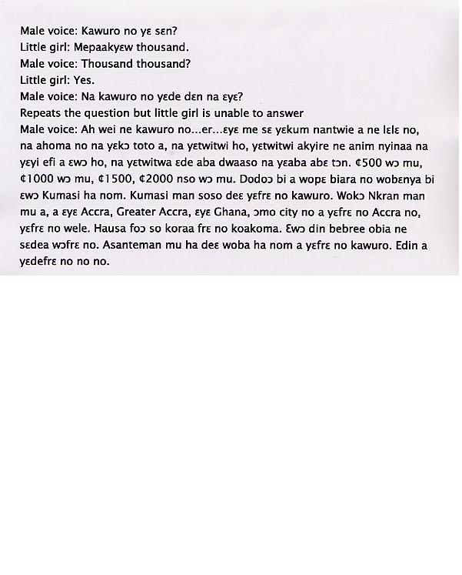

English translation:
"Male voice: How much is the ‘kawuro’ (Ghanaian delicacy made from cow-hide)?
Little girl: It’s a thousand.
Male voice: A thousand, a thousand?
Little girl: Yes.
Male voice: What’s ‘kawuro’ made of?
Repeats the question but the little girl is unable to answer.
Another male voice: Well, this is kawuro. I think that when a cow is slaughtered, its skin or hide is roasted and scrubbed thoroughly and then sliced and brought to the market to sell. They have ¢500 quantities, ¢1000 quantities, ¢1500, ¢2000 are also available. Whatever amount you need is available in Kumasi. In Kumasi it’s called kawuro. When you go to Accra, Greater Accra region where Ghana’s capital city Accra is located, it’s called wele. Hausa people also call it koakoma. It has many names; each tribe has its own name for it. In the Ashanti area it is called kawuro. That’s what it’s called."

About Language by Country: The Language by Country videos and other materials were produced by the Five College Center for the Study of World Languages between 1999 - 2003 with funding from the National Security Education Program (NSEP) and the Fund for the Improvement of Postsecondary Education (FIPSE) of the U.S. Department of Education. The videos were filmed by Five College international students in their home countries. The goal was to provide examples of authentic language spoken in its natural cultural environment so that students of all ages can better understand the interplay between a language and its culture. We have tried to remain true to the language our subjects actually uttered. Therefore, we have not corrected grammatical errors and the videos sometimes show highly colloquial language, local slang, and regionally specific speech patterns. At times, we have noted the preferred or more standard forms in parentheses. Most of the transcripts and translations were prepared by the same students who filmed the video, although in some cases the transcripts have also been edited by a language expert.
© 2003 Five College Center for the Study of World Languages and Five Colleges, Incorporated

