Czech in Czech Republic Video Transcripts
Language by Country Collection on LangMedia
http://langmedia.fivecolleges.edu/

"A Restaurant Meal"

Czech transcript:
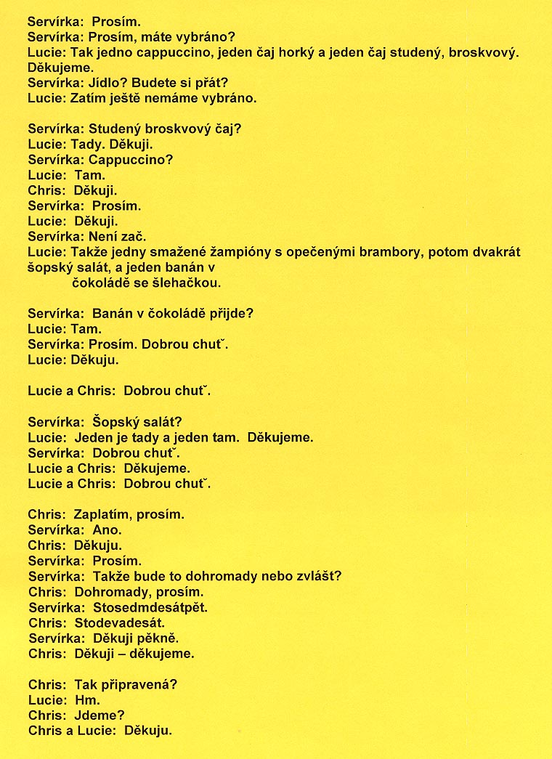

English translation:
"Waitress: Here you go (take the menu).
Waitress: Have you decided?
Lucie: So, one cappuccino, one hot tea and one iced tea with peach flavor. Thank you.
Waitress: Would you like any food?
Lucie: We haven't decided yet.
Waitress: Peach iced tea?
Lucie: Here, thank you.
Waitress: Cappuccino?
Lucie: There.
Chris: Thank you.
Waitress: You are welcome.
Waitress: Please.
Lucie: Thank you.
Waitress: Not at all.
Lucie: So, one fried mushrooms with baked potatoes, then two „Sopsky„ salads (vegetables with vinaigrette and cheese), and one banana in chocolate with whipped cream.
Waitress: Banana in hot chocolate will go...?
Lucie: There.
Waitress: Please. Enjoy your meals.
Lucie: Thank you.
Lucie and Chris (to each other): Enjoy your meal.
Waitress: „Sopsky„ salad?
Lucie: One here and one there. Thank you.
Waitress: Enjoy your meal.
Lucie: Thank you.
Lucie and Chris (to each other): Enjoy your meal.
Chris: May I please pay?
Waitress: Yes.
Chris: Thank you.
Waitress: You're welcome.
Waitress: Together or separately?
Chris: Together, please.
Waitress: 175.
Chris: 190 (includes tip).
Waitress: Thank you very much.
Chris: Thanks, thank you.
Chris: So, are you ready?
Lucie: Mmm.
Chris: Let's go.
Lucie and Chris to the waitress: Thank you."

About Language by Country: The Language by Country videos and other materials were produced by the Five College Center for the Study of World Languages between 1999 - 2003 with funding from the National Security Education Program (NSEP) and the Fund for the Improvement of Postsecondary Education (FIPSE) of the U.S. Department of Education. The videos were filmed by Five College international students in their home countries. The goal was to provide examples of authentic language spoken in its natural cultural environment so that students of all ages can better understand the interplay between a language and its culture. We have tried to remain true to the language our subjects actually uttered. Therefore, we have not corrected grammatical errors and the videos sometimes show highly colloquial language, local slang, and regionally specific speech patterns. At times, we have noted the preferred or more standard forms in parentheses. Most of the transcripts and translations were prepared by the same students who filmed the video, although in some cases the transcripts have also been edited by a language expert.
© 2003 Five College Center for the Study of World Languages and Five Colleges, Incorporated

