Bangla in Bangladesh Video Transcripts
Language by Country Collection on LangMedia
http://langmedia.fivecolleges.edu/

"A Pizza Order"

Bangla transcript:
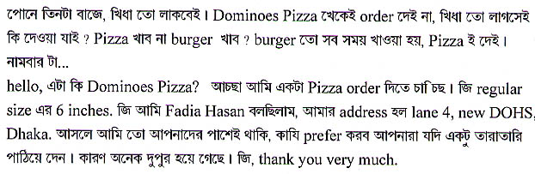

English translation:
"--It’s quarter of three, no wonder I’m hungry. Let me order from Domino’s Pizza. After all I am very hungry. What should I order? Should I go for pizza or a burger? Okay, I always eat a burger, I might as well go for a pizza. Now for the number...
--Hello, is this Domino’s Pizza? Okay, I would like to order a Domino’s pizza. Yes, a regular size, six inches. Yes, this is Fadia Hasan speaking. My address is Lane 4, New DOHS, Dhaka. Actually, I am right next to you, so I hope you can send my order quickly because it is pretty late in the afternoon. Yes, thank you very much."

About Language by Country: The Language by Country videos and other materials were produced by the Five College Center for the Study of World Languages between 1999 - 2003 with funding from the National Security Education Program (NSEP) and the Fund for the Improvement of Postsecondary Education (FIPSE) of the U.S. Department of Education. The videos were filmed by Five College international students in their home countries. The goal was to provide examples of authentic language spoken in its natural cultural environment so that students of all ages can better understand the interplay between a language and its culture. We have tried to remain true to the language our subjects actually uttered. Therefore, we have not corrected grammatical errors and the videos sometimes show highly colloquial language, local slang, and regionally specific speech patterns. At times, we have noted the preferred or more standard forms in parentheses. Most of the transcripts and translations were prepared by the same students who filmed the video, although in some cases the transcripts have also been edited by a language expert.
© 2003 Five College Center for the Study of World Languages and Five Colleges, Incorporated

